Griffin HLRV (Heavy Lift Rescue Vehicle)

Urban Disaster Response

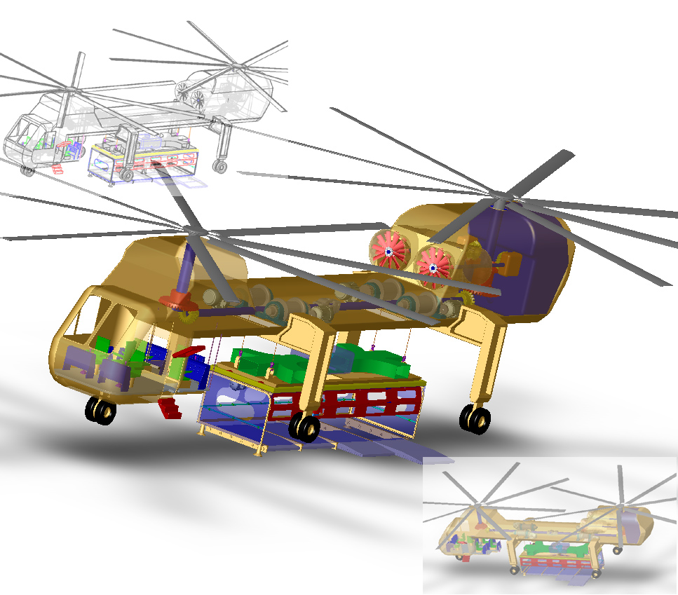

Department of Aerospace Engineering
The Pennsylvania State University
University Park, Pennsylvania 16802
June 15th, 2003

The Pennsylvania State University



Department of Aerospace Engineering
The Pennsylvania State University
University Park, PA 16802

VTOL Urban Disaster Response Vehicle

In response to the 2003 Annual American Helicopter Society Student Design Competition- Undergraduate Category
June 15, 2003

____________________ ____________________
Michael Duffy - Team Leader Edward C. Smith -Faculty Advisor

____________________ ____________________
Jacques Hoffler Barnes McCormick -
Faculty Advisor
____________________ ____________________
Eric Parsons Matthew Fether

____________________ ____________________
Robert Clauser Mayank Pandey

Acknowledgements

We would like to extend our greatest appreciation to our faculty advisors Dr. Edward Smith and Dr. Barnes McCormick. The entire aerospace department at the Pennsylvania State University also deserves our thanks for their continual help during the duration of this project. Lastly, we would like to thank each of the individual members who participated in the completion of this design competition. This truly was a group effort that could not have been completed without the total corporation of all those involved.

Table of Contents

List of Figures vi
List of Tables vii
Abbreviations and Symbols viii
1. Introduction 2
2. Requirement Compliance Matrix 2
3. Technical Compliance Matrix 3
4. Mission Requirements and Design Features 4
4.1 Mission Requirements 4
4.2 Design Features of the Griffin HLRV 6
5. Operating Environment 11
5.1 Denver’s 95th Percentile Summer Day 11
5.2 Operating Temperature 12
5.3 Urban Layout 16
5.4 Existing Fire-Fighting Helicopters 17
6. Detailed Mission Profiles 17
6.1 High Rise Firefighter Deployment 17
6.2 Rooftop Occupant Extraction 18
6.3 Building Face Penetration & Occupant Recovery 18
6.4 Water Cannon Firefighting 19
6.5 Command and Control Platform 20
7. Down Selection Process 21
7.1 Selection of Aircraft Configuration 21
7.1.1 Configurations under Consideration 21
7.1.2 Design Criteria Used to Evaluate Each Configuration 22
7.1.3 Criteria Explained: 22
7.1.4 Comparative Matrix 23
7.2 Endurance: 24
7.3 Selection of Rescue Method 24
7.3.1 Conveyer 25
7.3.2 Sky Bridge 25
7.3.3 Repelling Platform 26
7.3.4 Clamping Device and Module 26
7.4 Selection of Vertical Transportation Method 26
7.5 Selection of Module Stabilizing Device 29
7.6 Selection of Clamping Device 32
7.7 Selection of Multiple-Mission Modules 35
8. Vehicle Drawings and Subsystem Descriptions 36
8.1 3-View of Griffin HLRV 37
8.2 3-View of L.I.F.E Module 38
8.3 3-View of Command and Control Unit 39
8.4 3-View of Hoist System 40
8.5 3-View of Clamping Device 41
8.6 3-View of F.I.R.E. Module 42
9. Weight Derivation 42
9.1 Useful Load/Design Load for Existing Helicopters 43
9.2 Payload Derivation 43
9.2.1 Crew Members/Rescue Victims Weight 43
9.2.2 Empty L.I.F.E. Module Weight 44
9.2.3 Cable Weight 45
9.2.4 APU (Auxiliary Power Unit) 45
9.2.5 Hydraulics Weight 45
9.2.6 Clamping Device Weight 45
9.2.7 Hoist Weight 46
9.2.8 Stability System Weight 46
9.2.9 Estimated Fuel Required 47
9.2.10 Summary of Payload and Initial Gross Weight Estimate 47
9.3 Weight Matrix 48
9.3.1 SolidWorks Weight Matrix 48
9.3.2 Calculated Weight Matrix 50
10. Typical Call and Loading Procedures 52
10.1 Instructional Information Sessions 52
10.2 Emergency Call 53
10.3 Notifying Griffin HLRV Headquarters 53
10.4 Deployment of the System 53
10.5 Arrival at Disaster Site 53
10.5.2 High Rise Fire Fighter Deployment 54
10.5.3 Fire Fighter Deployment Acquisition Methods 54
10.5.4 Rooftop Occupant Extraction 54
10.5.5 Rooftop Extraction Acquisition Methods 55
10.5.6 Face Penetration Occupant Extraction 55
10.5.7 Disaster Command and Control 56
10.5.8 Water Deployment 56
10.5.9 Self-Contained Fire Fighting Method 56
10.5.10 Ground Pump Fire Fighting Method 57
10.6 Refueling 57
10.7 Mission Completion 57
11. Performance 57
11.1 Rate of Climb 57
11.2 Range 58
11.3 Forward Flight 59
11.4 Gross Weight Timelines 60
11.4.1 Rooftop Extraction 60
11.4.2 Building Face Penetration and Occupant Recovery 62
11.4.3 High-rise Firefighter Deployment 63
11.4.4 Ground Pump Water Cannon Fire Fighting 64
11.4.5 Self-contained Tank Water Cannon Fire Fighting 65
11.5 Hoist Performance 66
12. Cost Estimates 67
13. Development Schedule 69
14. Risk Identification and Risk Reduction Plan 71
14.1 Instructional Information Sessions 72
14.2 On Scene Risk Reduction Precautions 72
14.3 Post-Mission Risk Reduction Precautions 72
15. Number of Systems per 1,000,000 People 73
16. Concept Sketch of Future Station 73
17. Greek Mythology 75
18. References 76

List of Figures

Figure 5.1 Representative Daily Temps. (Highs) for a Denver summer 12
Figure 5.2 Temperature Rise above High-Rise Fire 14
Figure 5.3 Temperature of a Building Using an Infrared Camera 16
Figure 7.1 Conveyer, Sky Bridge, Repelling Platform, Clamping Device and Modules 25
Figure 7.2 Relations Between R/C and GW Based on Existing Helicopter Data 27
Figure 7.3 Gyroscopic Stabilizing Device 29
Figure 7.4 Various Ways to Support the Load 30
Figure 7.5 Horizontal Module Displacement vs. Wind Velocity 31
Figure 7.6 Propulsion Stabilizing System 32
Figure 7.7 Electromagnetic Clamping Device 33
Figure 7.8 Mechanical Clamping Device 34
Figure 7.9 Hydraulic Clamping Device 35
Figure 8.1 Griffin HLRV 3-View 37
Figure 8.2 L.I.F.E (Lightning Inhabitant Fire Evacuation) Module 3-View 38
Figure 8.3 Command and Control 3-View 39
Figure 8.4 Hoist System 3-View 40
Figure 8.5 Clamping Device and Stabilization Blower 3-View 41
Figure 8.6 F.I.R.E. (Fire Inhibiter and Rapid Extinction) Fighting Module 3-View 42
Figure 9.1 Useful Load vs. Gross Weight 43
Figure 9.2 The Convergence of the Iteration Process Used to Determine the Estimated Gross Weight. 51
Figure 11.1 Maximum Forward Flight Velocity to Building 60
Figure 11.2 Gross Weight Cycle Time for Rooftop Extraction 62
Figure 11.3 Fuel Depletion Rate for Rooftop Extraction 62
Figure 11.4 Gross Weight Cycle Time for Side Extraction 63
Figure 11.5 Cycle Time for Firefighter Insertion 64
Figure 11.6 Ground Pump Water Cannon Fire Fighting Timeline 65
Figure 11.7 Cycle Times for Self-contained Tank Water Cannon Fire Fighting 66
Figure 13.1 Development Gant-Chart 71
Figure 16.1 Day Time View of a Possible Griffin HLRV Fire Station, Located in the City 74
Figure 16.2 Night Time View of a Possible Griffin HLRV Fire Station in Action 75

List of Tables

Table 5.1 Denver, Colorado’s 95th Percentile summer day for three consecutive years 12
Table 7.1: Weighted Design Criteria 22
Table 7.2 Comparative Matrix of Design Criteria for Different Aircraft Configurations 23
Table 7.3 Estimated Gross Weights of the Aircraft Changes with Different Endurances 24
Table 7.4 Griffin HLRV Data 28
Table 7.5 Elevator/Hoist Data 28
Table 9.1 Summarizes the Weight Derivation for the Empty Module 45
Table 9.2 Summarizes the Weight Derivation for the Stability System 47
Table 9.3 Useful Load Determination 48
Table 9.4 SolidWorks Weight Matrix 49
Table 9.5 Aircraft Component Weights 52
Table 11.1: Mission-Specific Rates of Climb for Griffin HLRV 58
Table: 11.2 Hoist Performance Parameters 67
Table: 11.3 Motor Performance Parameters 67
Table 12.1 Gross weight ratio between the Calvert aircraft and the Griffin Aircraft 67
Table 12.2 The weight comparison of the Calvert to the Griffin, used to find the individual weight ratios for the cost estimation 68
Table 12.3 Cost estimates based on the weight ratios between the Calvert Aircraft and the Griffin Aircraft. 68
Table 12.4 Cost / Lb. of the several exciting heavy lift aircraft compared to the Griffin aircraft 69

Abbreviations and Symbols

Symbol: Description:

Description
AC Alternating Current

APU Auxiliary Power Unit

CAP Civil Air Patrol

CG Center of Gravity

DC Direct Current

EMS Emergency Medical Service

°F Fahrenheit

F.I.R.E Fire Inhibitor and Rapid
Extinction

ft Feet

gal Gallon

GHz Gigahertz

GW Gross Weight

HLRV Heavy Lift Rescue Vehicle

HP Horse Power

hr Hour

in Inches

IR Infrared

KW Kilowatts

Symbol: Description:

LAN Local Area Network

lbs Pounds

L.I.F.E Lightning Inhabitant Fire Evacuation

min Minute

mph Miles per Hour

M.T. Mission Time

NTSC National Television Standard Committee

psi Pounds per Square Inch

R/C Rate of Climb

RF Radio Frequency

RFP Request for Proposal

sfc Specific Fuel Consumption

SHP Shaft Horse Power

SSL Standard Sea Level

T-O Take Off

UL Useful Load

VHF Very High Frequency

VTOL Vertical Takeoff and Landing

Executive Summary (Sections 1-4)

1. Introduction

The Griffin HLRV is a fully equipped helicopter designed to rescue victims trapped in high-rise buildings. This helicopter was designed in response to the 2003 American Helicopter Society Annual Student Design Competition. The need for such a rescue system can be seen from the drastic events of September 11th that resulted in the destruction of both the World Trade Center towers. The primary focus of the design is to ensure the safe and efficient rescuing of victims trapped in high-rise buildings.

2. Requirement Compliance Matrix

RFP Requirements | Griffin HLRV  Characteristics | Reference  Section
Transport of 1200 people per hour from high rise rooftops | Rescue of 1400 people per hour | 6.2, 11.4.1
System landing on congested rooftops | L.I.F.E module uses retractable floors for rescue on congested rooftops. | 4.2, 6.2, 6.3
Delivery of 15 firefighters ever 2 minutes weighing 300 lbs, loaded with gear up to1500 ft. | Delivery of 123 firefighters per hour weighing 300 lbs with gear to 1500 ft. | 6.1, 11.4.3
Prolonged hover in urban canyons | Hover endurance of 2 – 3.5 hours depending on mission | 4.2, 11.4
Precision hover within 1 ft of selected position | Precision within 1 ft for flight vehicle and fully extended module | 4.2, 7.5
Position hold in zero visibility | Infrared/night vision displays allow operation in all conditions | 4.2, 6.3
Window penetration at any floor | Window penetration by in-module personnel and L.I.F.E modules ability to open one whole side with sliding floors. | 6.3
Extraction of 800 occupants per hour from window at any floor | Extraction of 800 victims per hour at any floor | 6.3, 8.2
Provide lift for 5 in diameter hose up to 100 stories | FIRE module provides lift for 5 in diameter hose up to 150 stories | 6.4, 8.6
Fire fighting on any floor by ground or on board system | Firefighting on any floor provided by F.I.R.E. module | 6.4, 8.6
Minimum of 500 gallons capacity in onboard tank | 4500 gallons of onboard water capacity | 6.4, 8.6, 11.4.5
Onboard tank refillable under 1 minute | Refillable tank rate at 500 gallons per minute | 6.4, 8.6, 11.4.5
Command and Control platform with 4 personnel | 4 stations for command and control, one located inside cockpit | 6.5, 8.3
Capability of simultaneous multiplexed communication on 6 communication frequencies | Simultaneous communication on 6 communication frequencies | 6.5
Development of horizontal and vertical tactical situation displays with overlays | Command and control unit provides personnel with HEADS up displays | 6.5.1, 8.3
Minimum flight endurance of 1 hour in hover and 1hour at 60 knots | Endurance of 2.5 hours in hover  Griffin HLRV can travel 375 miles before refueling | 7.2, 11.2, 11.3
Location of occupant in zero visibility | Onboard infrared occupant location cameras and displays | 4.2, 5.2
Generation of thermal maps | Onboard infrared thermal cameras and displays | 4.2, 5.2
Easy operation | Ease of operation by trained pilots and crew | 10.5.1
Capacity of 5000 lbs. External cargo | Reconfigurable external cargo capacity of 57,766 lbs | 9.3
Compliant with the Denver Colorado 95th percentile summer day | All performance and weight calculations were used at a density altitude of 8000 ft. | 5.1
Transportable on wide load flat bed truck | Modules capable of being transported on flat bed trailer | 4.2, 8.2, 16
Configuration of mission in under 20 minutes | Mission specific configuration reconfigured in 3 minutes | 4.2

3. Technical Compliance Matrix

RFP Requirement | Supplied In Report
Executive Summary | Supplied
Description of Operating Environment | Supplied
Description of Mission Requirements | Supplied
Detailed Mission Profiles | Supplied
Down Selection Process | Description with
Process | Illustrative Sketches
Concept Sketches | 3 View/Isometric
 | Drawings
Day in the L.I.F.E of the System | Supplied
Subsystem Description | Supplied
Avionics Description | Supplied
Mission Kit Descriptions | Supplied
Weight Empty Derivation | Supplied
Mission Gross Weight | Supplied
Performance Estimates | Supplied
Non-Recurring and Recurring | Supplied
Unit Cost Estimates Development Schedule | Supplied
Development Schedule | Supplied
Risk Identification and Risk Reduction Plan | Supplied
Number of Systems per 1,000,000 people | Supplied
Person City Population
Concept Sketch Future Urban Fire Station | Supplied

4. Mission Requirements and Design Features

The RFP specified approximately 23 design requirements, with the most important being the ability to safely transport a minimum of 1200 people per hour from high-rise rooftops that are on fire. To accomplish this, mission specifically designed modules will be implemented with the capability of carrying 200 people in high-density packing. With such a large number of people, weight obviously becomes an important factor to consider.

4.1 Mission Requirements

As it was deemed unlikely that all of the requirements of the design could be met satisfactorily, they were prioritized in a manner such that those considered most critical to the success of the missions would receive more attention.

The main concern of this design is saving the lives of the trapped victims. The inability to ensure the safety of the victims will deem the mission a complete failure. This puts “2) safely transport a minimum of 1200 people per hour from high rise rooftops to either the ground or adjacent rooftops” as being the first main accomplishment to be fulfilled. The second requirement would then be “9) Enable extraction of not less than 800 occupants per hour from windows at any floor when equipped with a window extraction mission kit”, since this is the second best way to rescue as many people as possible in the least amount of time.

Some minor requirements will need to be met in order to successfully accomplish the first two. These include: “3) Enable air vehicle or rescue subsystem landing on congested rooftops”, “20) The system shall be capable of performing all missions at ambient conditions represented by Denver Colorado on a 95th percentile summer day”, “8) Enable penetration of building windows at any floor”, “5) Enable safe and prolonged hover operations between high rise buildings”, “6) Perform precision hover, maintaining lateral separation form glass, steel, or concrete vertical surfaces within 1 foot of a pre-selected separation distance while maintaining altitude within 1 foot”, “7) Ability to sustain position hold hover in zero visibility conditions”, and “19) The system must have the ability to carry external cargoes of at least 5000 lbs to supply disaster relief materials or aid in the emergency removal of debris”.

During hazardous conditions, frightened victims have a tendency to panic and possibly hurt others in an attempt to save their own lives. In addition, some victims could be trapped or might need assistance to get to the rescue vehicle. Trained personnel should have a way to get to these victims to ensure that no one is left in the building as well as maintain order during victim evacuation. For this reason “4) Enable delivery of teams of 15 firefighters weighing 300 lbs each with gear to rooftops up to 1500 feet in no more than 2 minute cycles” was next on the list.

Fires need to be extinguished to aid in the rescue of all victims and clear the area for safe evacuation. If the building has been structurally damaged in some way, the internal water system may be inoperable. In this case a means of fighting the fire needs to be brought into the building to the scene of the blaze. Hand-held fire extinguishers are useless against large blazes, so next on the list is “11) Enable engagement of fires on any floor with a directed water cannon drawing from either the air to ground hose or by drawing from an optional onboard water tank of not less than 500 gallons.” There is the possibility that a water source isn’t closely available, so an onboard tank would be the best solution. This would require “12) The internal water tank, when installed, shall be refillable in under one minute from standing water sources or water supplies in adjacent buildings.” If a water source on the ground or an adjacent building is available, then it might be more efficient to use that source. This would require the vehicle to “10) Provide lift for 5 inch diameter water hoses capable of pumping 1500 gal/min to a minimum of 100 stories using ground mounted pumps or pumps positioned on adjacent rooftops. Mixing of additional fire retardants may be accomplished by ground systems.”

The rescue vehicle cannot be so complex that a crew of 10 is needed to perform the mission. Computers and other technological devices will be needed to simplify the operator’s tasks. Next on the list “18) The system shall be easy to operate and mission manage. The system shall be flown by a specially trained operator, but not a fully trained aviator. The operator shall be able to takeoff from a fire house, fly to a disaster site and precisely position the vehicle to accomplish mission tasks using simple commands.”

Time is critical during rescue operations. Therefore, it is helpful to have the ability to quickly adapt the vehicle to perform numerous missions. That is why “22) The system shall be reconfigurable from one mission configuration to another in less than 20 minutes” is next on the list. Along with this goes “23) The system shall be capable of executing any of the defined missions following a 20 minute deployment from a home base. System endurance for firefighter deployment and occupant extraction missions shall not be less than 1 hour.” Another way to save time would be “15) Navigation systems shall enable rapid and accurate response to street addresses.”

The utility of the vehicle will be increased if ground transportation is easily accomplished If the vehicle is too large, it will have to be taken apart so it can be transported in smaller pieces which could waste valuable time. Therefore the next requirement is “21) The system shall be transportable on a wide load flat bed truck on urban roadways.”

It was decided that the following are secondary to the aforementioned requirements: “13) Provide a command and control platform to disaster response decision makers to coordinate all aspects of disaster response. A minimum of 4 personnel is required with capability for simultaneous multiplexed communication on 6 different communication frequencies. The command and control variant shall be capable of developing horizontal and vertical tactical situation displays with overlays of data such as sensor information, maps, and building schematics”, “14) When configured for command and control the vehicle must have an endurance of not less than 2 hours, one of which is in a hover and 1 hour of which is in cruise at 60 knots”, “16) Sensor systems shall have the ability to locate occupants in zero visibility conditions. Sensors shall be capable of developing thermal maps of building structures”, and “17) Sensor data shall be able to be transmitted to other disaster relief systems on the ground and in the air”. The case may be where there isn’t enough time to fly around the building and collect data.

While it may be difficult to satisfy all the requirements listed above, a strong focus will be devoted towards accomplishing those aspects deemed most important for the mission by the group. This is not to say that the requirements listed towards the end of the list are going to be neglected. All requirements will be considered in the final design to provide the industry with the most efficient and realistic design possible.

4.2 Design Features of the Griffin HLRV

The Heavy Lift Rescue Vehicle is designed to function within the confines of an urban environment to assist in the rescue of occupants in high-rise buildings and contain fires in those buildings. Such needs have previously been unobtainable due to the inaccessibility of ground vehicles to the site of the disaster and the unavailability of a suitable VTOL aircraft to perform the aforementioned tasks.

In order to conceptualize such an aircraft, there was a need to blend in components and ideas from existing aircrafts while infusing these ideas with a fresh and bold line of reasoning. In the end, what is going to separate this aircraft from the rest will be the various design features which will enable it to perform tasks that have been previously unachievable. Some of the more prominent features of the Griffin HLRV are discussed in brief, below.

Tandem configuration was adopted due to its large payload capacity and its stability through a wide range of CG.

Ergonomic fuselage design reduces drag by allowing modules to fit within its confines.

Exchangeable module system provides the versatility necessary to perform a wide variety of missions without compromising the effectiveness of each mission.

A hydraulic clamping device offers the speed and reliability needed to secure the modules to the helicopter. The system allows for the quick exchange of modules to convert from one mission to another in a short time.

A STEADY© stabilizing system, attached to the clamping device, allows for precision maneuvering of the modules, preventing injury to the passengers while loading/unloading and preventing further damage to the building and surrounding areas.

Torsion-resistant cables, constructed of Spectra® and Technora® fibers, provide the strength needed to support the modules, as well as resistance to abrasion and creep.

High-speed hoists are used to reduce the time necessary to raise and lower the modules, allowing more time for safe passenger loading/unloading.

L.I.F.E© (Lightning Inhabitant Fire Evacuation) module provides the safe rescue of more than1400 people per hour to a safe location. The module may also be used for side extraction in the case that the roof is inaccessible. Furthermore, it has the capability to transport firefighters and medical teams to aid occupant recovery and firefighting.

Emergency medical supplies and fire-fighting equipment in the module allow for treatment of critically injured occupants and for localized fire control.

Sliding walkways ensure the safety of the victims while boarding the L.I.F.E module. Multiple walkways allow the module to accommodate for any building façade, while not compromising the safety of the passengers.

Safety rails on the sliding walkways prevent those occupants with injuries or who may have problems dealing with tall heights to carefully cross the walkway to the L.I.F.E module.

Lightweight composites, such as carbon-fiber reinforced plastic, minimize the weight of the structure and allow for a greater payload.

Cargo-carrying capability allows for up to 20 tons of disaster relief materials to be distributed at the scene. The module may also be used for emergency removal of debris to free occupants.

A directional water cannon is used for precision firefighting of the high-rise blaze. The water cannon are remotely controlled by personnel in the Griffin HLRV. The capabilities of the cannon range from a wide-area dousing of the inferno to pinpoint accurate fighting of areas that may prevent the rescue of occupants or could endanger the soundness of the structure.

Ground water pump, capable of pumping 500 gallons of water per minute to the aircraft, supplies adequate water to the water cannon for firefighting.

An onboard water tank can be used if a ground supply cannot be located. The tank can supply 4500 gallons of water to fight the blaze.

Flat bed tractor-trailers will be employed to transport extra modules, specially designed to fit on the bed, to the disaster site.

A disaster and command control unit, located in the helicopter, will coordinate the rescue/firefighting with ground personnel, additional air units, medical/firefighting personnel in the modules, and similar units in the building. Control of the module hoists, stabilizing system, and water cannon are managed by the command and control unit as well. The helicopter crew will comprise of two pilots, two communications officers, and two module controllers.

Global positioning satellite navigation ensures rapid response to any disaster.

Thermal camera capable of developing thermal images of building structures are used to efficiently locate inhabitants and weaknesses in the building structure caused by the fire.

Insulation protects the helicopter personnel and sensitive equipment from the heat of the conflagration.

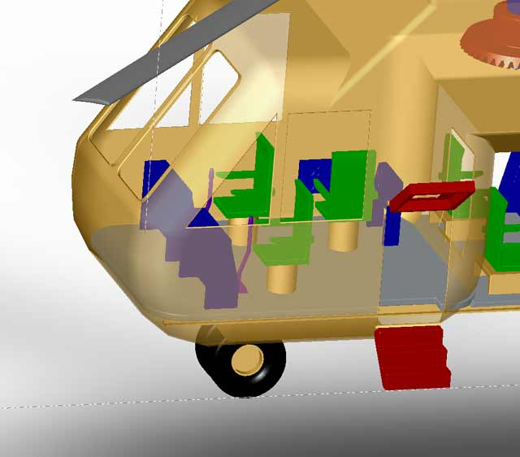

Three seated cockpit, 2-way opening door, with built-in stairs.

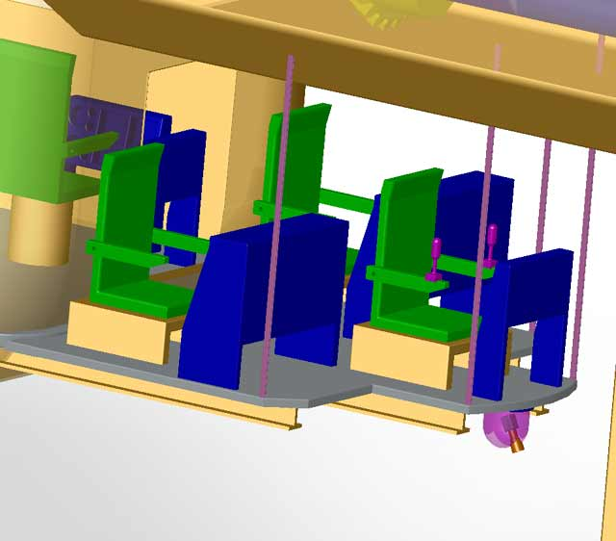

The command and control unit is located on the underside of aircraft. The location is critical for easy viewing of the disaster area. Heat resistant Plexiglas will surround the command and control unit. Completely open view on all sides.

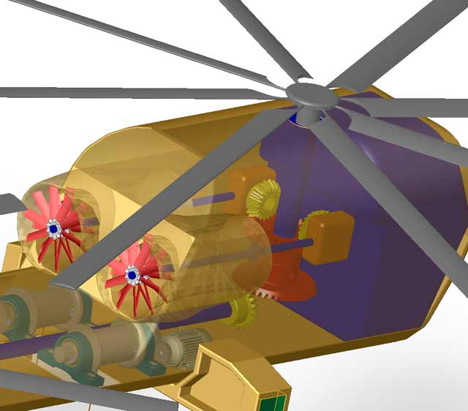

Twin 15,000 HP turbine engines provide the necessary power for all missions. The transmission is geared primarily for hovered flight. The two rotors are connected using a cross-shafting system.

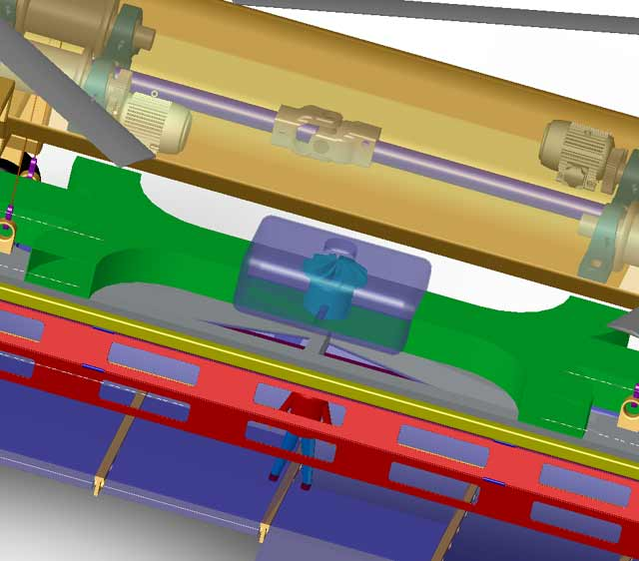

Stabilization system uses a ducted air fan and six air deposit vents. The stabilization system allows for 1 ft maneuverability of the modules in flight. This gives the command and control operators power over the modules movements in any environmental condition.

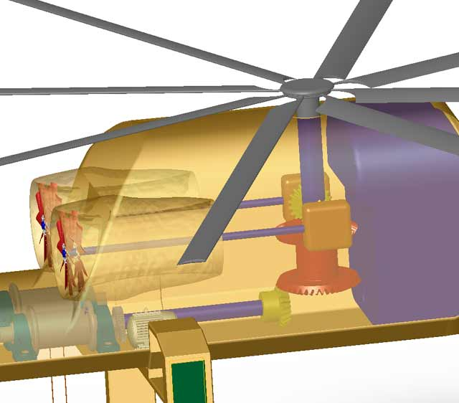

7920-gallon fuel tank can hold enough fuel to provide an endurance of 2 – 3.5 hours depending on mission.

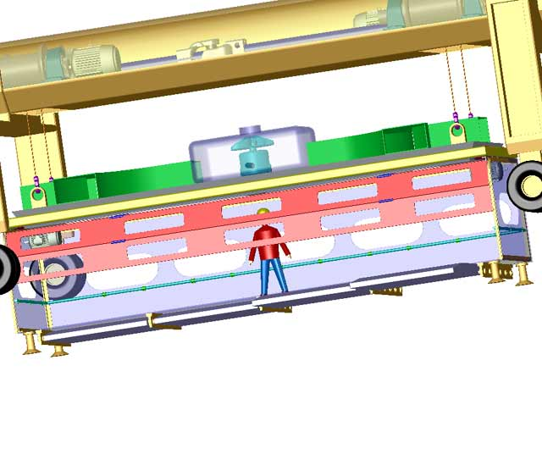
Vertical lifting 4-split garage style doors are mounted on tracks, and powered by twin 30 HP motors. The complete openness of the module allows for quick loading and unloading of passengers.

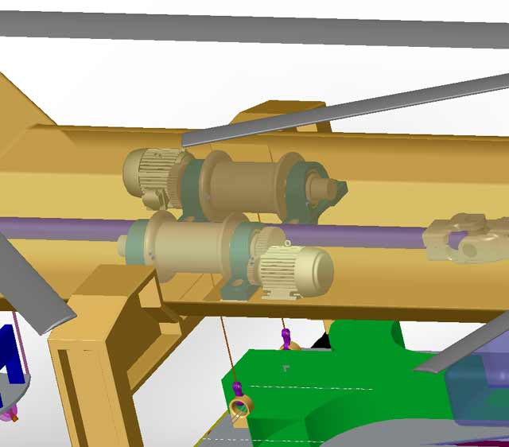

Four 160 HP motors drive the cable spindles for the lifting device. The cable and hoist system is capable of lifting 58,000 lbs at a rate of 1500 ft/min. This allows for quick raising and lowering of the rescue modules.

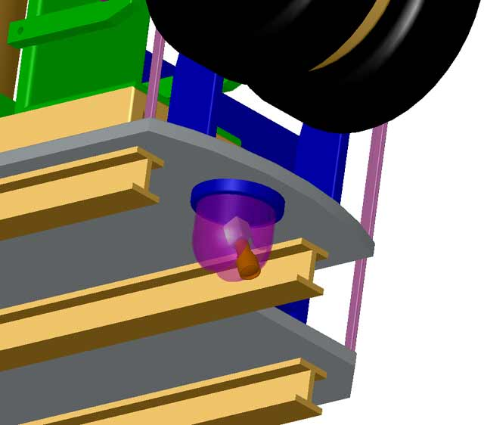

Three axes rotating infrared camera capable of obtaining images of the thermal swells, and color-coded temperature graphs.

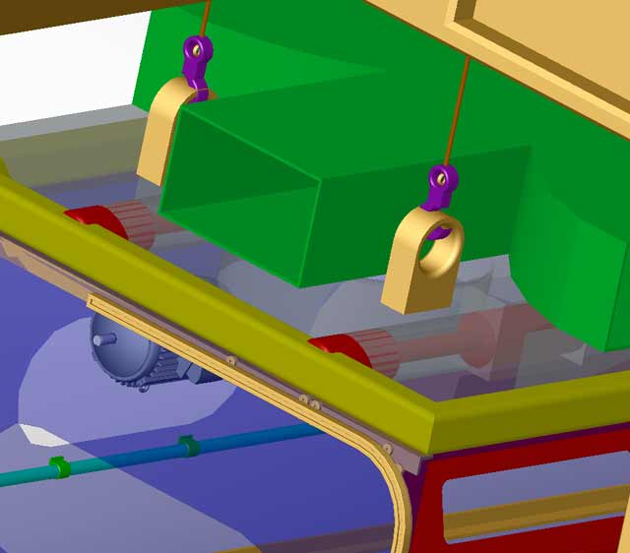

Quick release hydraulic pins allow for swift changing of modules between missions within 3 minutes.

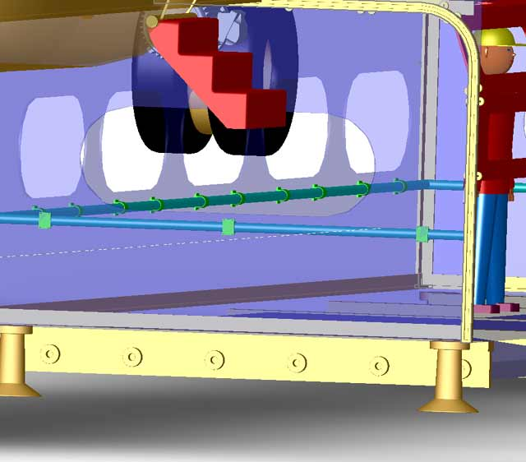
Safety railing runs along the inside of the L.I.F.E module passengers can hold on to the railing for support during turbulent flight.

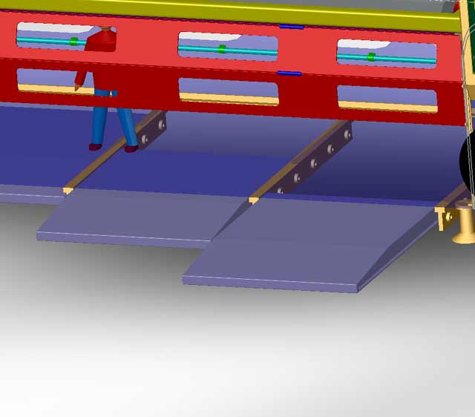

Retractable floors line the L.I.F.E module opening. The floors can accommodate any building face surface, or get rescuers closer to the building without flying to close. Can accommodate side extraction and congested rooftops.

5. Operating Environment

Current urban disaster response is limited by a number of factors. These include the operating temperature and conditions above an inferno, the compact layout of urban buildings, and the capabilities and limitations of existing helicopters. It was determined that the helicopter should be designed to operate under the most extreme environmental conditions it could face in an urban setting. To meet this requirement the ambient conditions of Denver, Colorado on a 95th percentile summer day were taken into consideration in the design the aircraft.

5.1 Denver’s 95th Percentile Summer Day

Using the Old Farmer’s Almanac, a table of data representing ambient conditions for a Colorado summer (June 21st – September 21st) was compiled. This data was based on an altitude of 5,881 ft and a density of 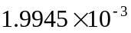slugs/ft³.

Table 5.1 Denver, Colorado’s 95th Percentile summer day for three consecutive years

Year | Max. Temp. [°F] | Min. Temp. [°F] | P (mean SSL) [Pa] | Wind Speed (mean) [mph] | Max. Gust [mph]
2000 | 95.0 | 60.9 | 102016 | 12.63 | 47.12
2001 | 97.0 | 63.0 | 102076 | 11.78 | 35.53
2002 | 98.1 | 62.8 | 101915 | 12.37 | 41.91

Based on the current specifications for existing Tandem rotor helicopters, the 95th percentile weather conditions for Denver provide a challenging environment for flight operations. For example, the CH-47F Improved Cargo Helicopter is required to be able to transport 16,000 lbs at 4000 ft and/or 95°F for an approximately 57.5 mi (50 nm) combat radius. In terms of the Griffin, the performance abilities were based on sustaining 2.5 hrs of flight at an altitude of 8000 ft.

As made evident through the graph below, a typical summer day in Denver has high temperatures ranging from the upper 90’s to the mid 60’s. Nevertheless, in order to propose a reliable rescue device, the upper limits of these temperatures were targeted for system requirements.

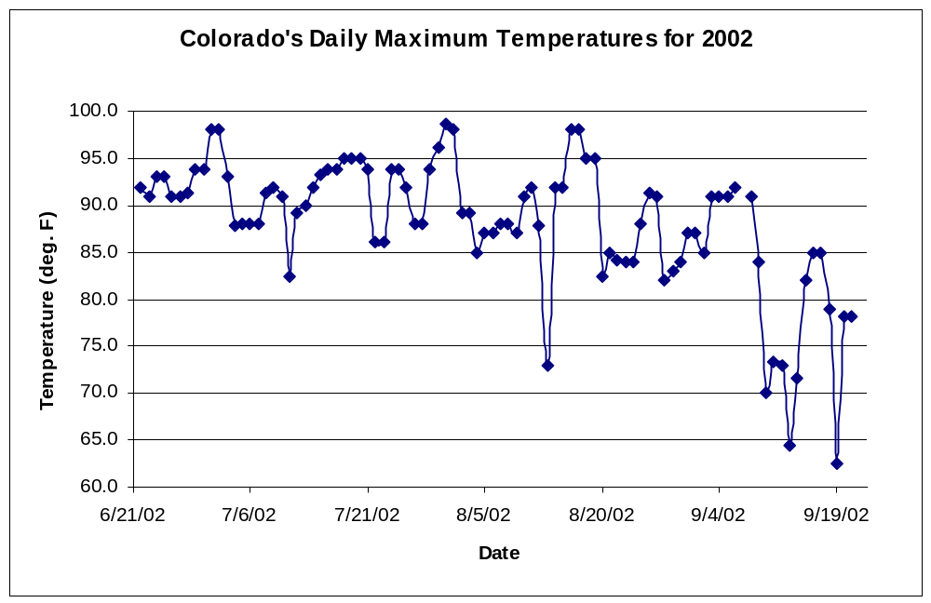

Figure 5.1 Representative Daily Temps. (Highs) for a Denver summer

5.2 Operating Temperature

An important consideration when considering high-rise rescue is the fire conditions above the building in question. Building fires are characterized by intense local fires, and often include fire plumes extending far above the building. Such extreme conditions can significantly affect the helicopter. Engines are typically designed to operate within a range of temperatures below typical fire conditions. Performance degrades with increasing temperature, and it is possible that the conditions above the fire may lower performance enough to cause handling problems with the aircraft or even cause the aircraft to crash. Furthermore, the fire temperatures must not make both the vehicle and the rescue device(s) inoperable. The electronic equipment in the helicopter, for example, is very sensitive to temperature and could malfunction if not protected.

To determine the conditions above the high-rise building, the mean flame height and change in temperature with height were determined. The mean flame height marks the level where combustion reactions are complete and the inert plume begins. To calculate the height of the fire plumes, the following equation may be used:

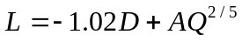 (5.1)

where L is the height of the flame, D is the diameter of the fire, A is a coefficient equal to 0.235, and Q is the total heat release rate (in kW) given by

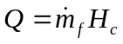 (5.2)
where 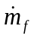 is the mass burning rate and H_{c} is the lower heat of combustion.

Notice that using equation (5.1), negative flame heights may be calculated for small heat release rates. This is, or course, impossible; in such situations, the flaming area breaks down into several smaller zones and equation (5.1) becomes invalid.

For analysis purposes, data derived from the fires occurring in the World Trade Center on September 11, 2001 were used. The towers compare favorably with the requirements set forth in the RFP. Each tower was 110 stories, with the north tower being 1368 ft tall and the south tower being 1362 ft tall. Each tower had a square planform with each side being 207 feet (63.1 m). Therefore, the area of the tower is 42849 ft² (3981.6 m²), corresponding to a circular area with a diameter of 233.57 ft (71.2 m). For the analysis, it is assumed that the fire dominates the entire planform, and this diameter will be used in equation (5.1).

For large jet-fuel pool fires, the heat release rate per unit is approximately 2 MW/m². If it is assumed that the jet-fuel has spread across the entire planform of the building, the total heat release rate may be found:

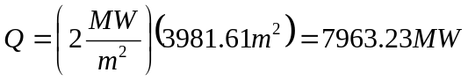

From this, the mean flame height is given by:

This corresponds to a flame height of 205.8 feet above the building.

The change in temperature from the origin of the fire to the top of the fire plume may now be found using:

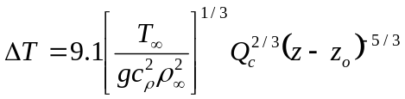 (5.3)

where T∞ is the ambient temperature (310 K for 95% Denver conditions), C_{p} is the coefficient of pressure, ρ∞ is the ambient density (.94406 kg/m³), Q_{c} is the convective heat release rate, z is the elevation above the fire source, and z₀ is the elevation of the ‘virtual origin’ above the fire source. This may be set to zero when the plume is predicted at high elevations, as in this case. Q_{c} is assumed to be 80 percent of the total heat release rate, Q.

Using this method, the temperature rise above the building as a function of height is shown in Figure 5.2.

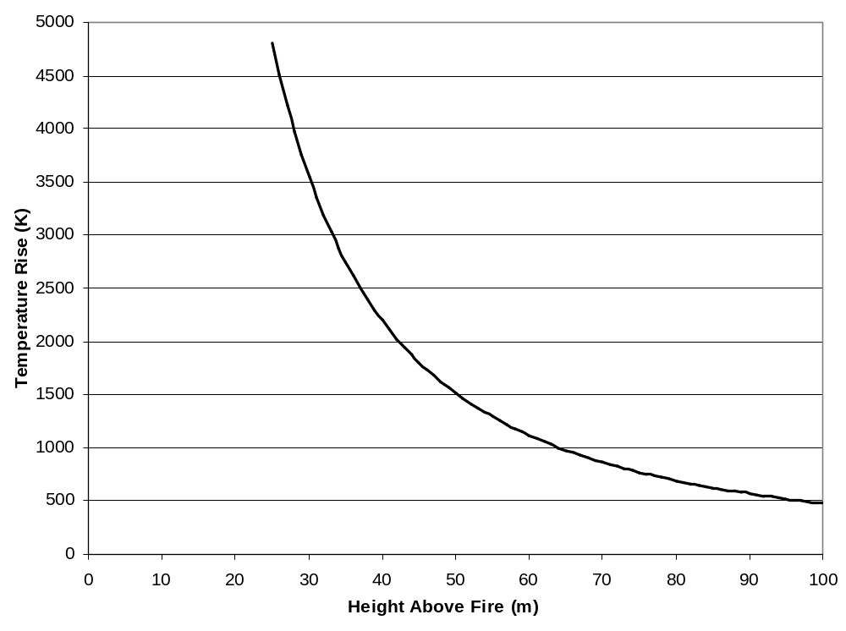

Figure 5.2 Temperature Rise above High-Rise Fire

The vehicle will be designed to safely fly and complete missions at a temperature of 950 degrees Fahrenheit, allowing the rescue vehicle to safely approach within 70 meters of the fire. This, of course, is an extreme condition in which rescue of building occupants would likely have been achieved by other means and only firefighting was needed.

A set procedure will be in place for all pilots intending to land on a burning building. There are two basic procedures in which the pilot will follow. The first will be a judgment on how close the landing zone (the roof or side extraction) is from the flames. An appendix will be present on board for the pilots quick reference which refers to the approximate temperatures of the air above the fire based on approximate height to landing zone and fire size. The pilot can then choose the fire size by class, and decide if it is too hot to proceed with the mission. The second procedure will be an infrared camera mounted on the Command and Control Unit, which will display a digital read of the building with a color display at the cockpit to display exact temperatures of the given shot. This will allow pilots an accurate and safe way of determining air temperature above the fire.

The first procedure can give the pilot a quick reference to avoid timely image capturing; however, the models used to determine air temperature above a fire determined make many assumptions, and may produce erroneous answers. The first procedure is useful for time-constrained missions, but more hazardous. The pilot determines the class of the fire and makes a decision based on the temperature charts. The pilot can also reference the graph and note the approximate height for the landing zone or mission zone. Winds, building geometry and materials being burned have a significant effect on temperature of the air above the fire; therefore, the first procedure is only for quick reference or last resort. The second procedure will give the pilot an exact temperature reading using the inferred camera but is costly in time.

Figure 5.3 demonstrates the display of the infrared camera, and what the pilot will use to determine air temperature above the fire. Procedure two would consist of the on board Command and Control Personnel taking an infrared picture of the building and determine weather the mission is with in safe operating limits, as stated above.

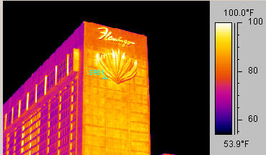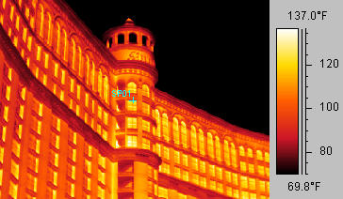
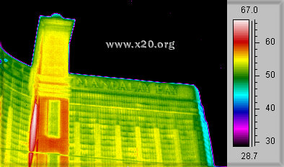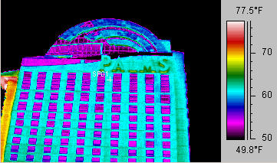

Figure 5.3 Temperature of a Building Using an Infrared Camera

5.3 Urban Layout

Because of the tight operating conditions in an urban setting, it was necessary to research the layout of an average American city. Using this, the limitations on the size of the vehicle, as well as possible landing locations for loading and unloading could be determined.

New York City was chosen for the study, as it represents a likely location when an urban rescue vehicle might be used. Using maps of the city, it was found that the average distance between high-rise buildings was approximately 100 feet. Therefore, to safely operate in an urban environment, the critical rescuing components of the design must not exceed these limitations.

Maps of the city were also used to determine possible landing zones for the aircraft. It was found that helipads or traditional landing pads were not numerous. However, for an emergency, sites such as parks, parking decks, school athletic fields, and other open areas can be taken into consideration. The average distance from a building to one such site can be assumed to be no greater than five miles.

City streets will be used to allow the use of tractor-trailers to successfully transport the rescue system to meet the requirements of the design competition. This places limitations on the dimensions of the rescue system used. The standard flat bed tractor-trailer was found to be between 48 to 53 feet in length. In addition, a cargo exceeding 8 feet in width may be considered a wide load.

5.4 Existing Fire-Fighting Helicopters

A comparison was done of existing fire-fighting helicopters used today with what kind of environment they can withstand. This was used to validate that the Griffin HLRV could withstand the operation conditions put forth by the mission.

There are currently no rotorcraft produced that are built purposefully for high-rise firefighting or rescue. The helicopters used for fire and rescue are generally a mix of anything the department or organizations can procure, with a few notable exceptions. The US Coast Guard uses the SA 365 Dauphin (and its variants), manufactured by Eurocopter, for its rescue operations. It does not, however, possess any notable fire-fighting or rooftop rescue capabilities.

Sikorsky has recently completed a variant of its popular UH-60/S-70 helicopter, deemed the ‘Firehawk.’ The UH-60L was modified with a removable 1,000-gallon water tank, and extended landing gear. The tank may be filled via a side connector and pump when the helicopter can land next to a source of water. Alternatively, a snorkel hose and pump may be used to suck up water with the helicopter hovering over the water source. This allows for faster refilling times. Using this method, the 1,000-gallon tank can be filled in under a minute.

The Firehawk recently completed a demonstration period for the Los Angeles County Fire Department, for potential buyers of the design. In one instance, the Firehawk dropped 37,300 gallons of a water-foam mixture on a fire at Lake Piru, refilling its tank 38 times in only three hours.

6. Detailed Mission Profiles

During the beginning and end of each mission, there are common procedures that are followed throughout. At the beginning of each mission, the appropriate personnel enter the module with their gear. The helicopter then hovers overhead and extends the clamping device. It clamps onto the module and the clamping device is raised to the underside of the helicopter. With the module secured in place the pilot flies to the urban disaster location. At the same time, flat bed tractor-trailers transport additional modules to the disaster site. Once the helicopter has successfully completed all missions, it will load the modules onto flat bed trailers. The clamping device is retracted to the underside of the helicopter. The helicopter can now fly back to the base. The modules are then brought back to the fire and rescue station on flat bed trailers.

6.1 High Rise Firefighter Deployment

The firefighter deployment mission will require the L.I.F.E module to be loaded with the mandatory 15 firefighters weighing up to 300 lbs each. Then, the L.I.F.E module is clamped to the helicopter using the clamping device. The module is then lifted and flown to the site. The rescue unit is lowered into place using standard rooftop landing procedures. The firefighters and rescue personnel are unloaded and the helicopter is deployed for ground replenishment. The module can either be flown to a loading zone where more firefighters can be loaded or the L.I.F.E module can be lowered using the hoist system.

The maximum amount of firefighters that the module can hold is 123; this is based on the 37,000 lbs allotted for passenger payload. This far exceeds the required 15 firefighters deployed in 2-minute cycles. The larger firefighter capacity improves efficiency of the operation because all the firefighters are deployed at once.

6.2 Rooftop Occupant Extraction

The L.I.F.E. module is responsible for safely transporting minimum 1200 people per hour from the disaster. The mission begins with the standard preflight and loading of the L.I.F.E. module. Together the flight vehicle and the L.I.F.E module will be capable of transporting 1400 people per hour from the top of a burning building. With the module secured in place the pilot flies to the urban disaster. Arriving at the scene the pilot positions the L.I.F.E module at rooftop level and opens the side doors so that firefighters and rescue personnel can begin loading victims. At the completion of loading, the side bay doors are closed. The pilot maneuvers laterally away from the building and lowers the L.I.F.E module between the buildings to ground level. The L.I.F.E module is unclamped and an empty module is then attached. In contrast, the module can also be hoisted upwards into flight mode and the vehicle can fly to a safe loading zone, depending on mission conditions, where a new module can be attached. The new L.I.F.E module is raised to rooftop level and the cycle is repeated. For congested rooftop extraction, the retractable floors can be employed when the module is hovering on the edge of the rooftop.

6.3 Building Face Penetration & Occupant Recovery

Building Face Penetration and Occupant Recovery has many technical challenges. The rescue vehicle will need to provide safe and prolonged hover operations between or above high-rise buildings. The ability to sustain position in hover during zero visibility conditions is also a requirement, as well as the capability to perform precision hover within a 1 ft displacement range. The rescue vehicle needs to be able to penetrate through windows at any floor and extract at least 800 occupants per hour.

Fifteen specially trained fire fighters acquire gear and load onto the rescue module at the beginning of the mission. Once the building is reached, the helicopter positions the module along side of the building, remaining well above the high temperatures. The doors are opened; the fire fighters will stand along the open edge of the module. The stabilizing system pushes the module within one foot of the building’s outer wall. Retractable floors can be extended if the windows are not on the outer face. The fire fighters walk out onto the walkways if needed and break the windows. The occupants are assisted out of the windows and helped to the back of the module.

Once all the occupants in that area are rescued, the module can be moved to the next rescue location either by lowering the module, or moving the helicopter along the side of the building. The stabilizing system is used to make fine adjustments to the module’s position. The occupants enter the module; once full, it is then lowered to the ground in a suitable location and the rescue personnel help the occupants out. The unloading location is to be predefined by the ground crew. If another module is ready to go, the full module will be left behind to unload. A new module can be clamped and used to save time. This process is repeated until all the occupants have been rescued.

6.4 Water Cannon Firefighting

To facilitate firefighters in controlling blazes, the Urban Disaster Response Vehicle must provide lift for a five-inch diameter water hose up to a minimum of 100 stories from a source of water located on the ground. Ground pumps must be capable of pumping 1500 gal/min through the hose to the water cannon on the firefighting module. Additional fire retardants may be mixed on the ground. The water cannon must have the ability to engage fires on any floor of the building, and have use of either the ground hose or an onboard water tank as a source for its water cannon. To meet the minimum requirement of carrying not less than 500 gallons of water, the on board tank must be capable of being loaded with 4,850 lbs of water.

The proposed F.I.R.E module (separate from the L.I.F.E. module) would incorporate both the water cannon and the self-contained water tank. A small pump would be located in the module to allow water cannon use with the self-contained tank. A larger pump would remain on the ground and be taken by trailer to the site of the fire. The F.I.R.E module will be operated by the command and control unit. The water cannon operator, located in the disaster control console, would control the water cannon by means of a joystick and heads-up display unit. Infrared sensors would be on hand to provide information on the temperature variations of the blaze, allowing the water cannon operator to target the most critical areas of the fire. The operator would also be responsible for coordinating with ground personnel manning the pump, firefighting units on the ground, and if necessary, fire-fighting units inserted into the building.

The water cannon operator has the option of switching between the onboard tank and the water hose as a means of supplying the water. When there is a readily available water source on the ground, most likely a fire hydrant in the nearby vicinity, the module will be lowered so the ground hose can be attached. After all connections are secure and the module is in position, the water cannon operator will signal for the pump and water to be turned on, allowing for water cannon firefighting at a rate of 500 gallons per minute. Working in conjunction with the stabilizing system operator, the water cannon operator may begin battling the blaze with the water being supplied by the ground.

If for some reason no source of water is readily available on the ground, the helicopter may fly to a lake, pond, or river in the surrounding area and use its onboard pump to fill the self-contained tank. The tank could also be used if the ground hose can not reach the height of the fire. Filling the tank shall take approximately eight minutes at a rate of 500 gal/min. If the ground pump is available, the onboard tank may be filled in approximately one minute, at a rate of 4500 gal/min, due to the heavier construction of the ground pump. After the self-contained tank is filled with water, the helicopter can position the F.I.R.E. module to extinguish the fire.

6.5 Command and Control Platform

Effective communication and access to critical information can be a major determining factor in the outcome of a disaster relief effort. In any case, the incident commander must be equipped with the tools necessary to survey the disaster and coordinate rescue efforts with personnel in the air and on the ground. Furthermore, the vantage point of a helicopter allows either the subordinates of the incident commander or the EMS command officer to have an unparalleled view of the site.

As a result, it is proposed that an enclosed station be housed in the exterior of the Griffin HLRV to serve as a platform for command and control operations. Within this structure, all of the necessary subsystems for “simultaneous multiplexed communication on six different communication frequencies” will be available. In addition, it will possess the ability to “develop horizontal and vertical tactical situation displays with overlays of data such as sensor information, maps, and building schematics.”

With Homeland Security and other national directives in place, more technology, than ever before, is now becoming available to civilian rescue personnel. For example, the Army’s Communications-Electronics Command, Raytheon, and other similar research and development agencies have proposed communication platforms to aid in the prevention of other 9/11-type disasters. Unfortunately, at this current time, these technologies are not certified for aircraft applications.

Nevertheless, other existing technologies could be assembled on the aircraft and work in conjunction with either the Army or Raytheon’s technological breakthrough devices. For example, Raytheon Corporation recently conducted tests with the Civil Air Patrol (CAP) to satisfy several objectives:

- Demonstrate the ability to display still images from the aircraft in the First
Responder using the CAP supplied equipment.
- Demonstrate the ability to send infrared still images from the aircraft to the ground using the CAP supplied equipment.
3. Demonstrate the ability to upload the images to the CAP website.
4. Demonstrate the ability to send video from the aircraft via the wireless LAN
to the First Responder.
5. Demonstrate the ability to link the airborne voice radio with different types
of radios on the ground.
- Demonstrate the ability to send video from the aircraft via the Falls Church
Video link equipment (Tactical Video Link).

The test equipment included the First Responder vehicle #1 with an e-Watch encoder connected to the internal LAN in the vehicle, a Cessna 206, a Cessna 182, the old version of the CAP Slow Scan system (CSI 100), a new version of the CAP Slow Scan system (AR 110), a Raytheon wireless aircraft subsystem, a Sony camcorder, a Raytheon Palm 250 infrared camera with a 100 millimeter lens and the Raytheon Tactical Video Link. The Raytheon wireless aircraft subsystem was contained in a Pelican module and consisted of power converters to provide 24 volts DC and 110 volts AC within the module, an e-Watch encoder to convert NTSC video to compressed video, a Cisco Bridge, and an RF amplifier. The wireless subsystem plugged into a 12 volt 5- 6 amp supply in the aircraft. An amplifier was also added to the vehicle between the bridge and the one of the 2.4 GHz antennas. The CAP supplied Slow Scan equipment consisted of a modem, power supply, and a VHF radio transmitter. This equipment accepted NTSC video and converted it to single frames for transmission to the ground. The ground equipment then converted the received VHF signal to NTSC video. The NTSC video from the Slow Scan ground unit was input to an e-Watch converter that converted it to compressed streaming video that was connected to the First Responder LAN.

The demonstrated use of this equipment lays the groundwork for the completion of the mission requirements.

7. Down Selection Process

After conducting a brainstorming session on various ways to rescue trapped victims it was necessary to narrow the ideas down to the most feasible and well-suited thoughts. To do so, the team went through the down selection process and evaluated each design. Trade studies were performed to determine the best solutions.

7.1 Selection of Aircraft Configuration

This section provides the analysis used to determine an aircraft configuration to perform the mission most efficiently. A comparative study of various aircraft configurations was conducted with respect to specific design criteria. It was decided to utilize concepts from existing helicopter configurations as opposed to designing a new one in the interest of cost and time. The end result of this analysis is the decision to implement and modify a tandem configuration.

7.1.1 Configurations under Consideration

The following seven configurations were evaluated to determine the design that best satisfies the criteria:

a) Conventional - Consists of one main rotor with an anti-torque mechanism.
b) Co-axial - Consists of two main rotors mounted on a single-axis. An additional anti-torque device is not needed.
c) Tandem - Consists of a front and rear main rotor system. Tandem does not require an anti-torque device.
d) Tilt Rotor - Consists of two main rotors on each wing that may rotate to be used as propellers or helicopter rotors. Tilt Rotor enables fixed-wing and helicopter modes.
e) Synchropter - Consists of a side-by-side intermeshing rotor configuration.
f) Compound - Involves a lifting wing in addition to the main rotor or the addition of a separate source of thrust to the main rotor.
g) X-wing - Employs a unique rotor system that uses circulation control.

7.1.2 Design Criteria Used to Evaluate Each Configuration

Table 7.1 below indicates the important criteria used to evaluate each of the seven aforementioned configurations.

Table 7.1: Weighted Design Criteria

Important Design Criteria | Weight
Hover Efficiency | 10
Cruise Efficiency | 5
Maneuverability | 7
Lifting Capability | 10
Small Size | 8
Crew Capacity | 8
Endurance | 9
Reliability | 10
Controllability | 8
Gross Weight | 7

7.1.3 Criteria Explained:

a) Hover Efficiency - Due to the fact that the helicopter will be allotting the majority of its time to rescuing victims, hover efficiency is of extreme importance, thus the weighted value of ten.
b) Cruise efficiency – While important, it is not deemed essential to the mission since hover is the primary mode of flight and the assumption that a safe landing zone is not extremely far away is made. It is not realistic to expect the vehicle to hover long periods of time with as well as cruise quickly with a heavy load.
c) Maneuverability – It is necessary for the pilot to have ease of maneuverability to navigate between buildings to operate in a tight urban setting.
However, since the helicopter is primarily in hover mode extreme acrobatics are not necessary.
d) Lifting Capability - The ability to achieve high-density packing of victims to save as many victims as possible forces the aircraft to have a high lifting capability.
e) Small Size – Since the environment of operation is mostly urban areas, a small aircraft is most ideal. The smaller the aircraft the more capable it is to fly between buildings and tight places. However, because the payload of people is expected to be substantial a relatively small aircraft may not be feasible.
f) Crew Capacity – There must be sufficient crew in the helicopter to operate all on board systems and communicate with the ground control team. The crew will include those needed to fly the aircraft as well as personnel to receive and give instructions to the ground.
g) Endurance- To save time between refueling of aircraft, endurance is necessary. A minimum operating time of 2.5 hours before refueling is needed.
h) Reliability- It is unacceptable to encounter non-human error during performance of the mission. All systems must be 100 percent reliable.
i) Controllability- Since the helicopter will be maneuvering in urban areas with the possibility of high density packing of buildings, it is necessary to have ease of control of the aircraft. The aircraft should be very stable.
j) Gross Weight – Since the aircraft will be carrying a large payload, the configuration should have an above average gross weight.

7.1.4 Comparative Matrix

The Comparative Matrix below indicates the weights for each of the prescribed design criteria as they correspond to the different helicopter configurations. From this matrix the aircraft configuration is selected.

Table 7.2 Comparative Matrix of Design Criteria for Different Aircraft Configurations

Criteria | Weight | Conventional | Co-axial | Tandem | Tilt Rotor | Synchropter | Compound | X-Wing
Hover Efficiency | 10 | 10 | 9 | 10 | 5 | 10 | 7 | 9
Cruise Efficiency | 5 | 6 | 6 | 6 | 8 | 7 | 10 | 8
Maneuverability | 7 | 5 | 3 | 4 | 4 | 4 | 5 | 4
Lifting Capability | 10 | 5 | 6 | 10 | 5 | 5 | 6 | 6
Small Size | 8 | 6 | 6 | 3 | 3 | 6 | 4 | 4
Crew Capacity | 8 | 2 | 2 | 8 | 4 | 3 | 3 | 3
Endurance | 9 | 7 | 7 | 5 | 5 | 6 | 4 | 5
Reliability | 10 | 7 | 6 | 6 | 8 | 6 | 6 | 6
Controllability | 8 | 5 | 7 | 5 | 5 | 6 | 6 | 5
CG Travel | 10 | 5 | 5 | 9 | 6 | 5 | 6 | 5
Gross Weight | 7 | 5 | 6 | 10 | 8 | 6 | 7 | 5
Total |  | 537 | 536 | 651 | 505 | 539 | 524 | 504

7.2 Endurance:

Endurance was considered to be one of the most important aspects of the design. Having a long endurance means that the Griffin HLRV would not have to refuel as often; therefore, allowing more time for rescue operations. It was determined that having a longer endurance would have an adverse effect on weight. Table 7.3 displays how the gross weight increases with endurance time. This increase in weight is caused by the larger amount of fuel required to operate for a longer time. The larger fuel amounts also increase the power required which enlarged the engine and drive components.

Table 7.3 Estimated Gross Weights of the Aircraft Changes with Different Endurances

Endurance: |  | 1 Hour | 1.5 Hours | 2.0 Hours | 2.5 Hours
Disk Loading |  | 17.24217 | 17.9072 | 18.72322 | 19.77946
Two Disks | Disk Area (ft²) | 7722.647 | 8274.806 | 8978.446 | 9931.977
One Disk | Disk Area (ft²) | 3861.324 | 4137.403 | 4489.223 | 4965.989
 | Radius (ft) | 35.05849 | 36.29017 | 37.80164 | 39.75831
 | Blade Area (ft2) | 490.3881 | 525.4502 | 570.1313 | 630.6806
Number of Blades = 8 | c (ft) | 1.748464 | 1.809892 | 1.885273 | 1.982858
 | Power, single (hp) | 22131.24 | 24913.32 | 28657.7 | 34079.91
Overlap | Power, tandem (hp) | 25229.61 | 28401.19 | 32669.78 | 38851.09
RPM | (Rev/Min) | 197.4769 | 190.7745 | 183.1466 | 174.1332
Torque | Q_{R} (ft*lb) | 670739.2 | 781583.5 | 936497.7 | 1171335
Fuel | W_{F} (lb) | 10091.85 | 17040.71 | 26135.82 | 38851.09
Payload | W_{P} (lb) | 57766 | 57766 | 57766 | 57766
Basic Weight | W_{B} (lb) | 65297.32 | 73371.91 | 84203.56 | 99832.04
UL/GW |  | 0.523898 | 0.518319 | 0.511744 | 0.503579
Est. Gross Weight | W (lb) | 133155.2 | 148178.6 | 168105.4 | 196449.1

7.3 Selection of Rescue Method

The rescue device serves as the backbone of the design objective. The design must work flawlessly in this department. The design is meant to be simple, yet effective in most situations that can occur. A simple comparison is made for each rescue device and a decision is reached that the clamping device and module is the most effective and reliable rescue method. The following ideas were evaluated and can be viewed in Figure 7.1.

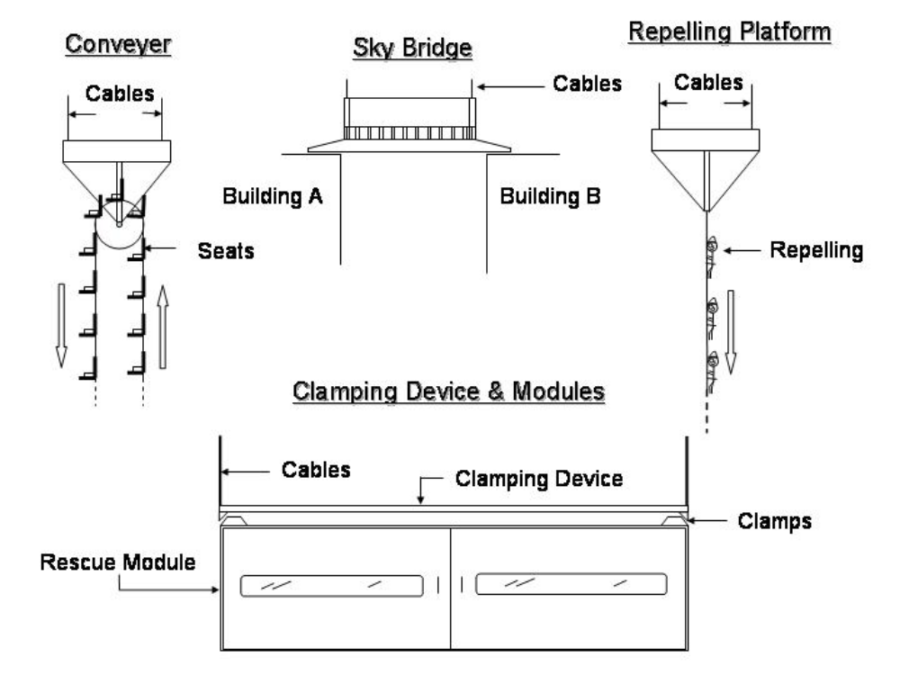
Figure 7.1 Conveyer, Sky Bridge, Repelling Platform, Clamping Device and Modules

7.3.1 Conveyer

The Conveyer can be lowered into place near the building edge and victims will be loaded on in small numbers as the helicopter suspends the conveyer. The Conveyer then lowers victims to the ground similar to a Ferris wheel. There are many obvious drawbacks to this concept. One drawback is the danger encountered when loading people close to the edge of the building. A special harness would have to be designed to secure the passenger before he/she got to the building edge. Another drawback is the low number of people that can be loaded at one time. The Conveyer would have to stop each time a new set of passengers was loaded or unloaded. Finally, there would have to be a long set of cables and chairs to span the required 1500 ft, which would render the design too complex and unfeasible.

7.3.2 Sky Bridge

The Sky Bridge can be lowered between two adjacent buildings by the helicopter and victims will walk across to the adjacent building. The sky bridge has many advantages. One advantage is the simplicity of the design. Another is the great number of victims that can be transported to safety. The Sky Bridge, however, has several serious drawbacks. The neighboring buildings need to be similar in height and close together. This eliminates the Sky Bridge as a constant solution because it is not adaptable to all situations; nevertheless, the sky bridge can possibly be a used as a situation specific solution in the final design under the correct rescue conditions.

7.3.3 Repelling Platform

The Repelling Victims solution allows victims to be lowered via a repel line to which victim will be strapped. The first issue would be how to lower injured victims without further injury. Also, it inhibits the deployment of fire fighters to the scene. This is the least feasible and least adoptable method.

7.3.4 Clamping Device and Module

The Clamping Device will be a permanent part of the helicopter, which is suspended by four cables and attaches the modules to the helicopter as an external load. This concept has the advantage of being very adaptable to almost any situation that may arise. The clamping device also allows for several different modules to be attached to the helicopter. A module can be made for people transportation, fire fighter deployment, and transportation between adjacent buildings via a Sky Bridge module. The design is also simple and can transport up to 200 people in each passenger carrier.

After considering the previous options, the Clamping Device and Module rescue system is the clear choice. The clamping device and module can accomplish all the designated missions with the highest efficiency compared to previous solutions. Because of the clamping device’s multitasking capability it is not limited to one particular mission. It is simple, fast, and more efficient compared to the previously proposed ideas.

7.4 Selection of Vertical Transportation Method

Once the vehicle design was chosen and the system of modules decided upon to perform the operations, the best method of utilizing the modules needed to be determined. Two methods were envisioned. The first method considered was where the module would be slung beneath the helicopter. The helicopter would be used to transport the module and its cargo vertically from the ground to the site of the disturbance via an onboard hoist. Afterwards, it could fly the victims down to the ground near the building or to a previously determined landing zone. The second method involved using the module in the manner of an elevator; that is, once the helicopter (with module) flew to the disaster area, it would remain stationary at the top of the building. The module would be lowered into place and, once full, lowered to the ground. The helicopter could then pick up another nearby module or maintain its position while the first was unloaded. The module could then be raised to resume its mission.

A trade study was conducted to determine which of these methods would be able to perform all required missions safely and effectively in the shortest amount of time. The feasibility of first scenario, using the helicopter as the primary ascent/descent device, would depend on the R/C of the aircraft, the frequency of suitable landing areas with the confines of an urban setting, the layout of the average city, and the distance between buildings.

The R/C for heavy lift helicopters currently in use were found and plotted as in Figure 7.2. From this data, the R/C for the team design was extrapolated and the times to traverse the building height determined. The layout of New York City was taken to represent the average city in the United States; from this, the distances between buildings were found and the availability of landing zones ascertained. Using these results, the time to complete each mission cycle was calculated and is explained in section 11.2 Gross Weight Timelines. The results can be seen in Table 7.4.

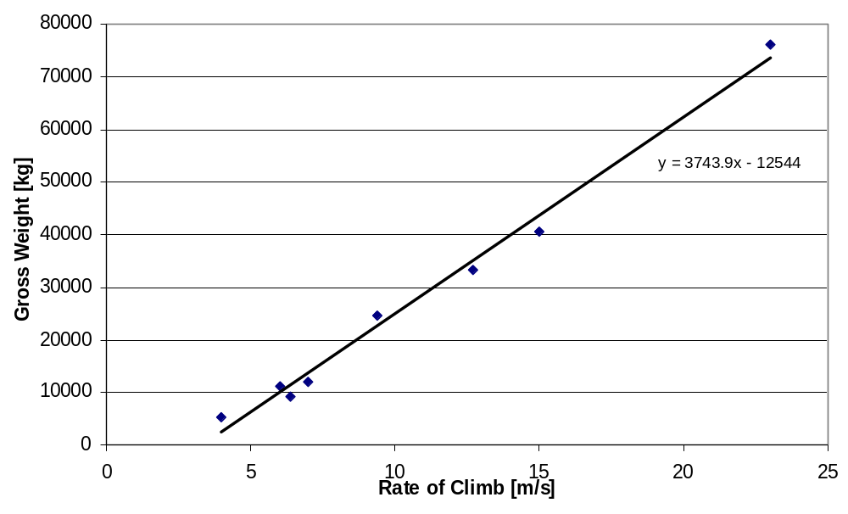
Figure 7.2 Relations Between R/C and GW Based on Existing Helicopter Data

Table 7.4 Griffin HLRV Data

Max R/C of Griffin HLRV (ft/min) | 5191
R/C with Max Load (ft/min) | 1500
Time of ascent/descent (min) | 1
Distance Between Buildings (ft) | 100
Average Distance Between Landing Zones (miles) | 5
Mission Cycle Times (min)
Rooftop Extraction | 7.9
Building Face Extraction | 14.2
Firefighter Deployment | 7
Ground Pump Water Cannon Firefighting | 60
Self-contained Water Cannon Firefighting | 19

The elevator scenario would be influenced by the availability of a suitable elevator/hoist. This would be determined by its speed of ascent/descent, its load capacity, and the weight of the system, as it would, out of necessity, be placed on the helicopter. Stabilizing the module as it traveled up and down is also a concern. Furthermore, as the cables used will undergo further strain and wear in this scenario, their condition is a concern as well.

Table 7.5 shows the rate of ascent, load capacities, and weights for currently available elevator/hoist systems. Through a further down-selection process (discussed later), a stabilizing mechanism was decided upon. The system should be able to maintain control of the module as it is being raised and lowered.

Table 7.5 Elevator/Hoist Data

Rate of Ascent (ft/min) | 1500
Max Load Capacity (lb) | 54,156
Weight (lb) | 2500

Moreover, existing cable was found that would satisfy the mission requirements. It is constructed of the synthetic fibers Spectra® and Technora®, and includes electrical conductors. The Spectra provides resistance to abrasion, while Technora eliminates creep. The rope is constructed of sixteen double-braided strands that are torque-balanced so the final rope is torque-free. The cable has a factor of safety of 10 and its ultimate strength is 61,000 lbs; stretch at failure is 5 percent.

The results of the trade study were inconclusive. Each method has its advantages and disadvantages in certain situations. For instance, there may be some areas in a city where a helicopter cannot fit between high-rise buildings. A suitable landing area may not be nearby. On the other hand, the stabilizing device may not be adequate in certain conditions, endangering the victims and rescue personnel in the module. Therefore, it was decided that the design should have the capability to perform either of the two scenarios. This manner offers the best possibility of accomplishing the required missions in a safe and efficient manner.

7.5 Selection of Module Stabilizing Device

Stability of the module is an important requirement that is essential to the success of all missions. Several methods were evaluated and a down selection process took place in order to determine the best stabilizing method.

The first method investigated was gyroscopic stabilization system. Gyroscopic control would provide attitude stability in each of the three planes, such as the systems currently used by satellites today. This type of system would allow the module to stay aligned with the buildings; however lateral forces such as those caused by wind gusts could destabilize the module. In addition, a gyroscopic system will significantly increase the gross weight of the design. Figure 7.3 below is a depiction of a typical gyroscopic system.
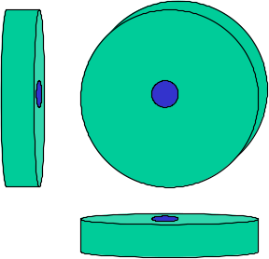
Figure 7.3 Gyroscopic Stabilizing Device

Next, several cable arrangements were examined to determine if one such configuration could provide the necessary stability in cross winds to accomplish the missions. The first configuration was to have a single cable attached to the center of the module from the helicopter. The second configuration was to have four cables descend from a common location on the underside of the helicopter and attach at the four corners of the module. The third configuration is to attach four cables to four separate locations on both the underside of the helicopter and four corners of the module. The following is a figure of the different cable stabilizing arrangements. The first one on the left is the single cable arrangement, the second one is the quad cable arrangement, and the last one is the arrangement that was finally chosen.
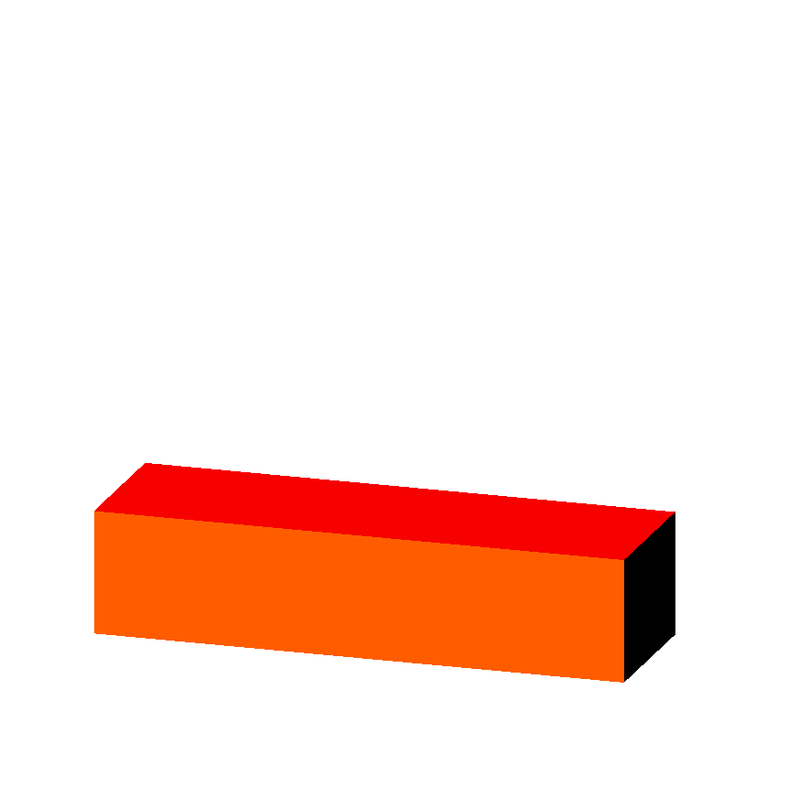
Single
Quad
Chosen
Figure 7.4 Various Ways to Support the Load

First the module was studied in various winds with the single cable hook up. If the largest side of the module (50ft by 7ft) is used, a 40mph wind creates a horizontal force of almost 1,800lbs. This force is capable of moving the module just over 25ft while dangling 1,500ft from the helicopter, as shown in figure 5. This proves that a single cable alone can’t satisfy the stability requirement.

The quad cable hook up will supply more stability than a single cable, but it needs to stop the module from moving more than one foot. Again using the larger side of the module with a 40mph wind, the module moves slightly more than 21ft, when hanging 1,500ft from the helicopter, as shown in Figure 7.5. This calculation assumes the cables are spread a distance of ten feet on the module and meet at a single point below the helicopter. This shows that neither cable configuration alone can provide enough stability to perform the various missions.

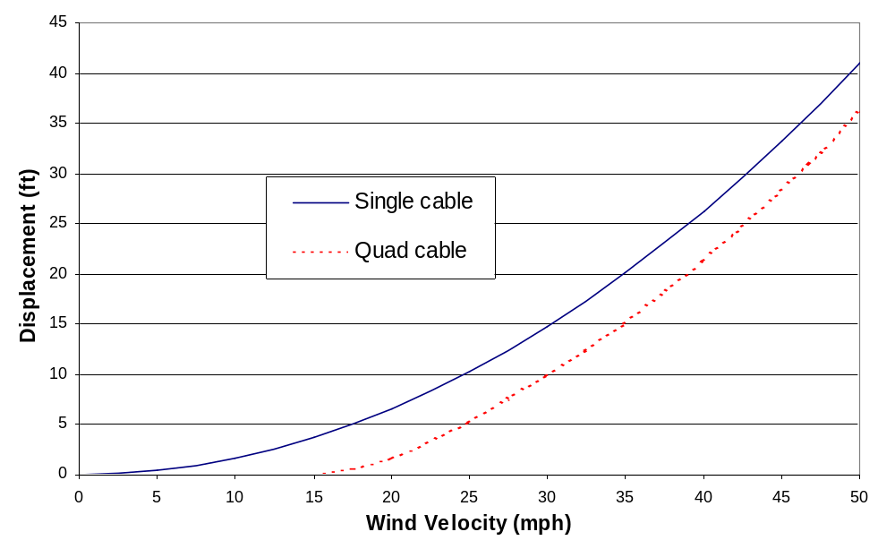
Figure 7.5 Horizontal Module Displacement vs. Wind Velocity

One can now suspect that a propulsion system is needed in order to keep the module stationary. It is logical to place the propulsion system on the clamping frame, so the redundancy of putting a system on every module can be avoided. The power needed for the propulsion system will come from an APU that is also mounted on the clamping frame. The APU will also provide power for the hydraulic system, and to an on board computer that will control the propulsion system’s valves to maintain a steady position.

Another question arose, as to which cable hook up to use in conjunction with the propulsion system. The quad cable hook up provides more stability than the single cable can, but the majority of the required stability can be supplied by the propulsion system. A similar quad cable system was chosen instead of the single cable. The smaller cables would be cheaper to produce, and the system’s safety would not rely on just one cable in the event of cable failure. The cables will be attached to the four corners of the clamping device and the other ends will be attached to the helicopter by four hoists that are separated the same distance as the corners of the clamping device. This type of cable system will provide the same stability as the single cable, except it will also provide twisting stability.

The propulsion system, as previously mentioned, shown in Figure 7.6 will consist of: a duct, valves, an air tank, an engine, an APU, an impeller, and a small computer system with sensors. The engine will constantly run with the impeller pushing air through valves and into the air tank. Valves will also be located at the ends of the duct openings; these will be controlled by the onboard computer system. When the module starts to move, valves will open to let some of the air out in order to counter act the force moving the module. The propulsion system will not be able to provide a large continuous force, due to the impeller’s limited capability of maintaining the pressure inside the air tank. It will, however, be able to provide short bursts of air to keep the module stable.
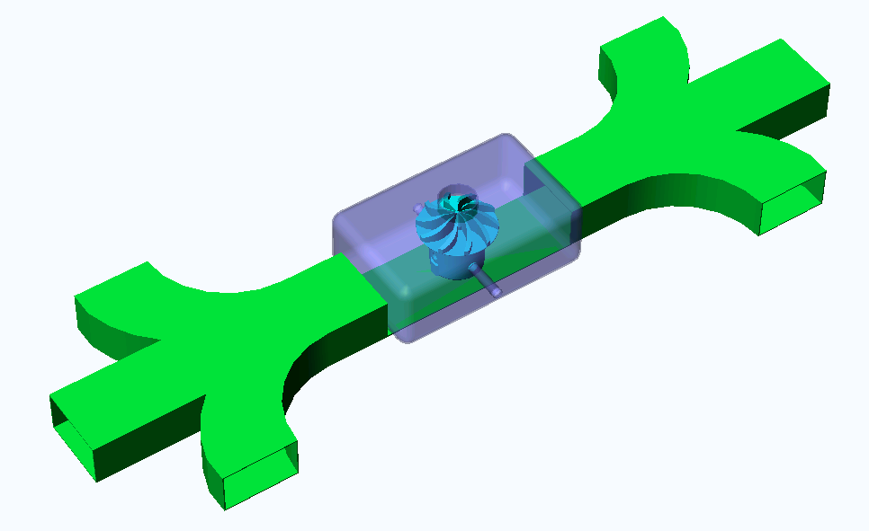

Figure 7.6 Propulsion Stabilizing System

The module design will be capable of sustaining a position, without deviating more than one foot from that desired location. The propulsion system will allow the modular module to perform its objective from a stationary horizontal location. The four cables will provide the lift and therefore control the vertical position of the module. The propulsive system can help align the clamping frame with the required module when the mission calls for a different module.

7.6 Selection of Clamping Device

Having decided to use mission specific interchangeable modules, the next step is to determine the method of attaching the module to the helicopter. Attachment and release of the module must be as efficient and rapid as possible. The device must also be able to support the required load of victims, rescue personal, equipment, and module structure.

Through brainstorming, some possible solutions to the clamping device problem were found. Electromagnets, mechanical clamping latches, permanent clamping, and hydraulically positioned support pins were considered and analyzed.

At first, electromagnetic attachment of the rescue module seemed promising. The advantages of the system were instantaneous attachment and release and also the self-centering properties of the magnet. The disadvantages of the electromagnetic system outweigh the advantages. The magnet must be able to lift two times the expected load to ensure safety. In addition, any deflection in the module caused by the load will create gaps between the clamping device and the top surface of the module, reducing the efficiency of the magnetic attraction and causing separation. This is an undesirable result.

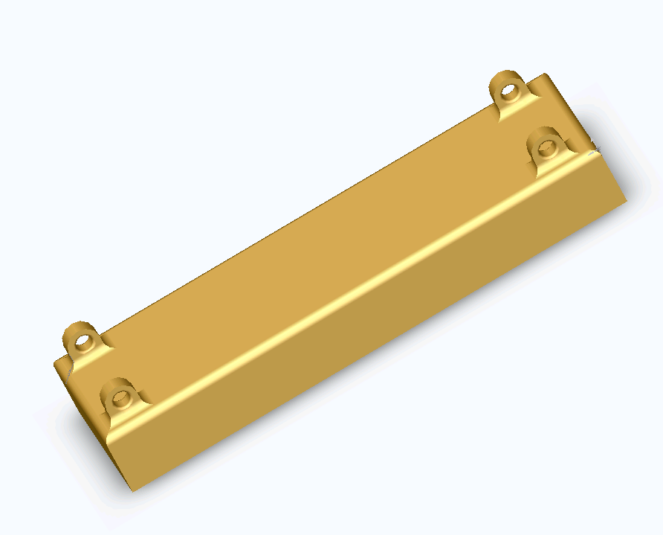

Figure 7.7 Electromagnetic Clamping Device

Three additional disadvantages that prompted the dismissal of an electromagnetic clamping device were sensitivity to heat, power failure, and weight. Electromagnets are also very susceptive to high temperatures. They begin losing their magnetic properties above 600 degrees Celsius. To create the magnetic attraction, a large amount of current is sent through coils of wire. If there were to be a power failure the load would drop immediately. Finally, the cast iron incased coils are very large and weigh much more than other possible solutions.

Mechanical clamping latches are design dependent. A simple locking latch such as spring loaded pins or manually locked clamps may not provide both quick and efficient attachment and release of the mission specific modules. Also mechanical clamping systems will be very heavy and will not allow for the fulfillment of the design requirements.
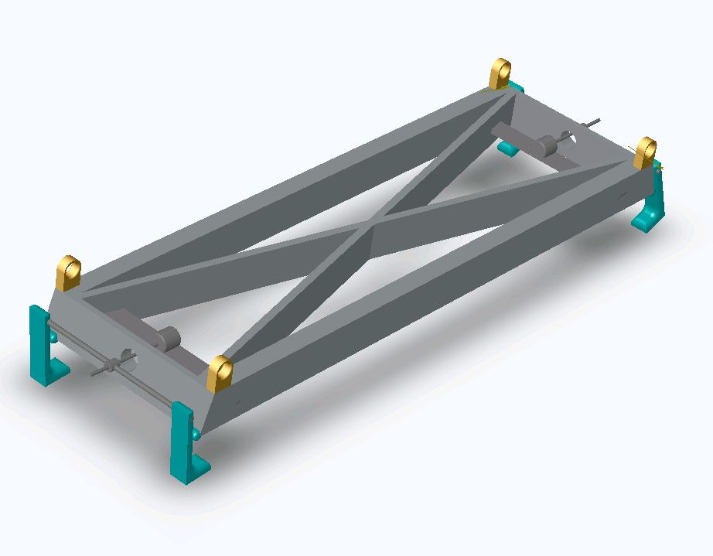

Figure 7.8 Mechanical Clamping Device

Permanent attachment of the module was also considered. However, after the use of multiple mission specific modules was decided, permanent attachment was eliminated as it would not allow for the interchangeability of the F.I.R.E module and the L.I.F.E module.

The final solution would utilize hydraulically positioned support pins. The use of hydraulics is wide spread throughout the industrial world. One disadvantage of hydraulics is the possibility of leaks and the necessity of filtering the fluid. Hydraulic fluid filled cylinders are capable of exerting great forces using minimal space and weight. Double acting cylinders move quickly and precisely in the extension and retraction directions. The fast action of the hydraulic cylinders allows for the reconfiguration/attachment of a new module in less than 3 minutes. Furthermore, hydraulic cylinders can be insulated to be resistant to high temperatures caused by a burning building. From these benefits, it was determined that a hydraulically powered clamping device system is the best solution to the problem.

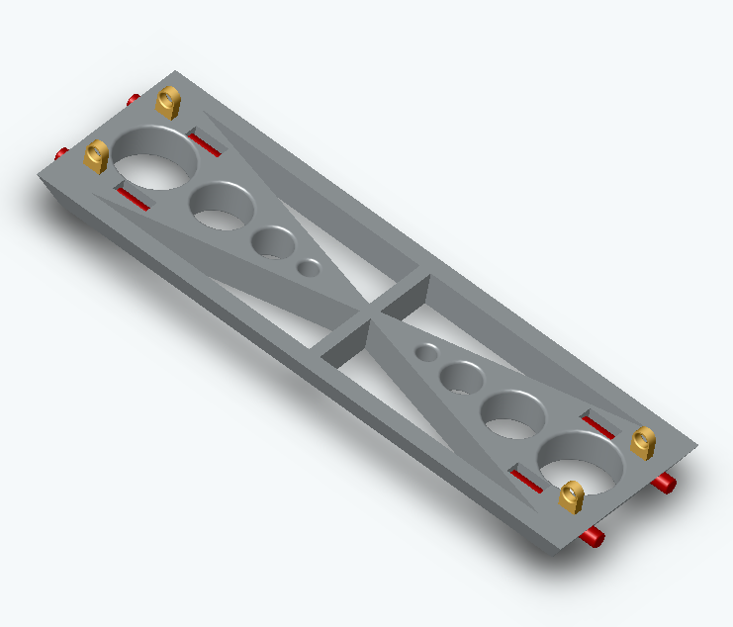

Figure 7.9 Hydraulic Clamping Device

7.7 Selection of Multiple-Mission Modules

In order to select a means of fulfilling the most important goals of the mission, it was decided that some sort of module-deployment system should be used for the rescue vehicle. Initially, five such modules were envisioned; two fire fighting modules, one side extraction, one roof top extraction module, and one fire fighter deployment module.

The two fire-fighting modules, as the name suggests, would primarily be responsible for carrying out the bulk of the fire fighting missions. It is proposed to carry fire-fighting equipment, including extinguishers, axes, water cannon, water storing container as well as first aid kits. One of the fire-fighting modules would be devoted to the onboard water supply capable of dosing the fire with water and the ability to refill the water supply via an onboard snorkel device. The second fire fighting module would be equipped to carry out fire fighting via the ground to helicopter water pump.

The primary purpose of the side-extraction module would be to assist in the extraction of individuals from the windows and sides of a high-rise building. This module would be equipped with sliding doors on the side (an effective open face) as well as another sliding mechanism beneath the door which would latch onto the side of a building, with the help of some sort of clamping device, forming a bridge that would connect the building to the module. This unit would also contain first aid kits and axes.

The rooftop extraction module would be used to extract people trapped on the rooftop of a high rise building on fire. This module will have sliding doors on the side, rather than a door on the front, for easy transportation of fire victims and a better control of traffic. It will also contain a first aid kit to provide immediate assistance to any of the victims. This unit will be lined with some sort of fire retardant material on the inside which would also serve as a cushion in case of any unexpected turbulence experienced by the helicopter. There will be rails on the inside as well to assist in the transportation of the fire victims.

Lastly, the fire fighter deployment module would be designed to carry only firefighters and deploy them at the site of the disaster. This module may also be used to load victims once the firefighters have been deployed if necessary. Such a module will save valuable time.

It was decided that combing the five above stated modules into two would benefit the consumer by reducing the cost of the rescue system. Although one multiple-mission module would be more costly than one single-mission module, it would be more cost-effective than three separate modules. This would allow many smaller cities the opportunity to purchase the system, improving rescue response time and increasing sales of the rescue vehicle.

Using three separate modules makes rescue difficult due to the need for the correct module to be on the Griffin HLRV at the correct instant. In contrast, if one module is used, the correct module is always attached and ready for operation. Taking these aspects into consideration, it was decided that the initial decision to have three separate modules was not as effective as one module containing the important aspects of each mission.

The two fire fighting modules were condensed into one module named F.I.R.E (Fire Inhibitor and Rapid Extinction). This module is capable of performing the tasks of the two separate fire fighting modules. The three victim rescue modules have been condensed into one module named L.I.F.E (Lighting Inhabitant Fire Evacuation).

8. Vehicle Drawings and Subsystem Descriptions

8.1 3-View of Griffin HLRV

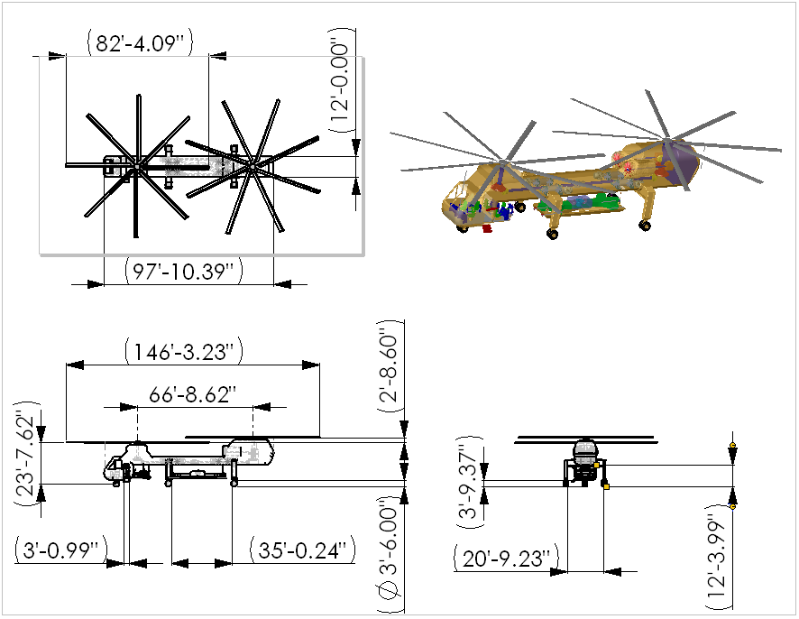

Figure 8.1 Griffin HLRV 3-View

Figure 8.1 shows the rotor diameter to be 82’4.09”, the available cargo width to be 20’9.23” and a height of less then 27’. The Griffin HLRV crew consists of 2 pilots, 1 navigator and communications officer, and 3 command and control officers. Each crewmember is equipped with an avionics or computer bay station. The Griffin HLRV is equipped with a clamping device that is powered by a 4-hoist system. The aircraft is an 8 bladed tandem helicopter with a total longitudinal span of 146’3.23”.

8.2 3-View of L.I.F.E Module

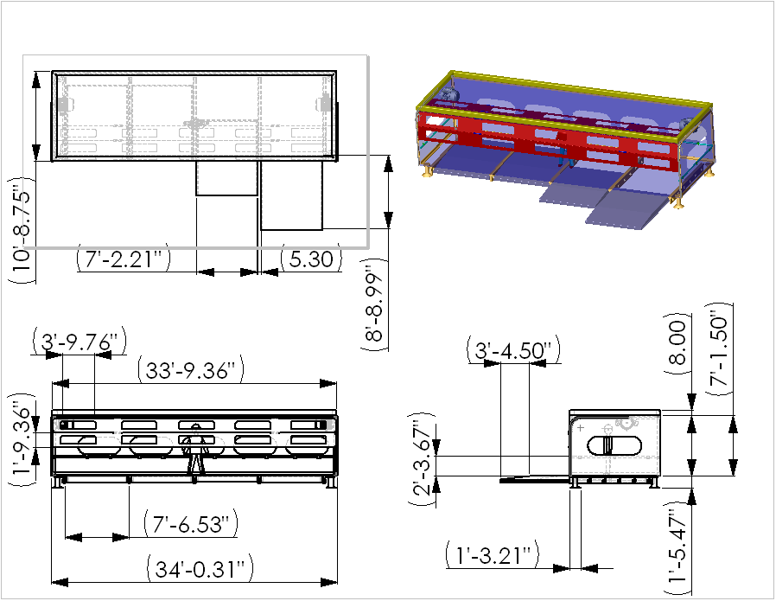

Figure 8.2 L.I.F.E (Lightning Inhabitant Fire Evacuation) Module 3-View

Figure 8.2 is the L.I.F.E (Lightning Inhabitant Fire Evacuation) module, which is capable of holding 200 passengers in high-density packing. The L.I.F.E module is equipped with fire resistant epoxy skin, and landing feet capable of resisting impact. Four retractable flooring devices 7’2.21” in width line the length of the module. The L.I.F.E module is capable of storing equipment and fire fighters for quick response to a high rise fire. Considering that cargos exceeding 8 ft in width are considered wide loads, the L.I.F.E module is an oversized load but within the RFP requirement. In addition, the standard flat bed trailer is 48 ft to 53 ft in length, which easily accommodates the 34 ft L.I.F.E module.

8.3 3-View of Command and Control Unit

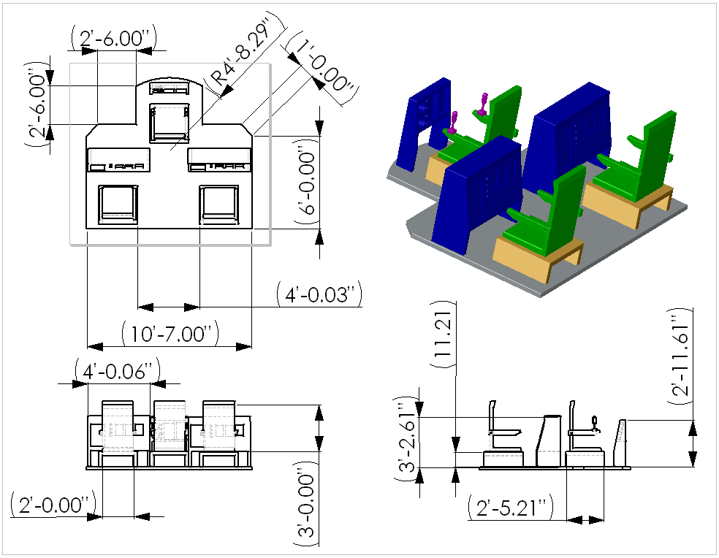

Figure 8.3 Command and Control 3-View

The command and control unit is a 3-person crew device that allows for control of the clamping device as well as the stabilization device. The command and control unit is located on the underside of the Griffin HLRV and faces the clamping device. The command and control unit also is used to collaborate with ground crews and determine were the most assistance is needed via inferred cameras.

8.4 3-View of Hoist System

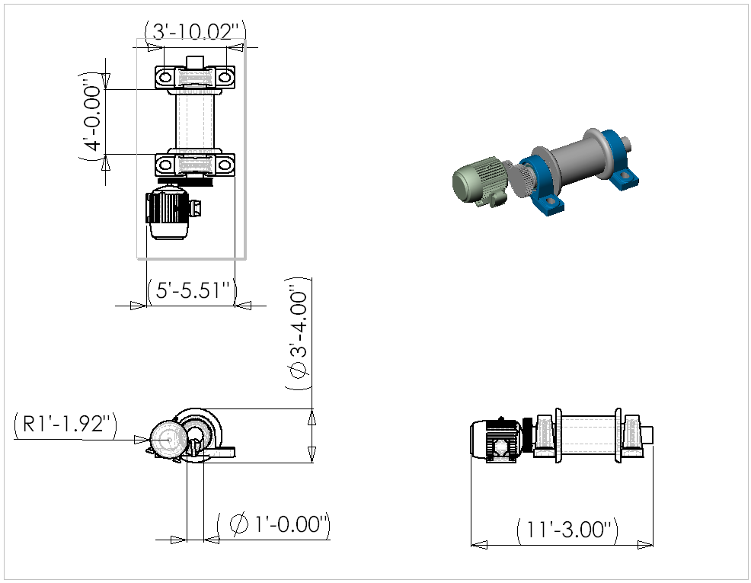

Figure 8.4 Hoist System 3-View

Figure 8.4 is the Hoist System which is capable of lifting and lowering the modules up to 1500 ft. In a confined environment, like a city, this feature can be utilized to lower the modules via the hoist system instead of having to fly the helicopter to a different location.

8.5 3-View of Clamping Device

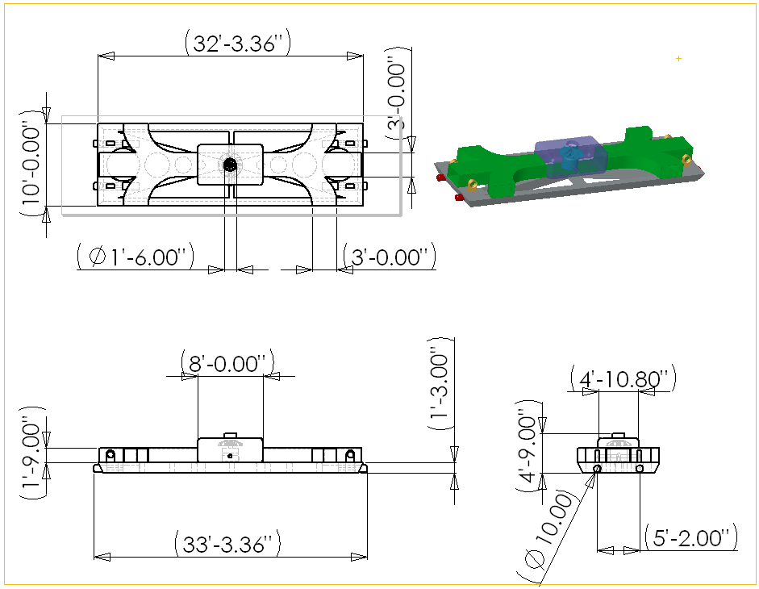

Figure 8.5 Clamping Device and Stabilization Blower 3-View

The clamping device found on figure 8.5 is the key component to the module idea. The modules are connected to the aircraft via the clamping device, which is a permanent part of the Griffin HLRV. The stabilization device, located atop the clamping device, is then used to maneuver the clamping device and module into place. Four hydraulic pins are used to connect the clamping device to each module. A sloped profile on the clamping device allows for easy connection to each module.

8.6 3-View of F.I.R.E. Module

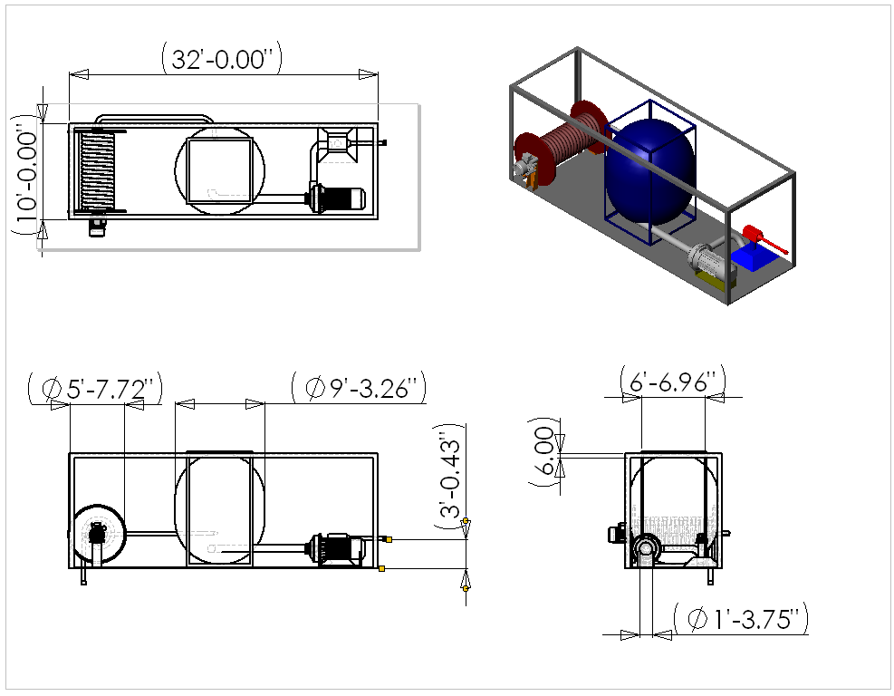

Figure 8.6 F.I.R.E. (Fire Inhibiter and Rapid Extinction) Fighting Module 3-View

Figure 8.6 displays the F.I.R.E. (Fire Inhibitor and Rapid Extinction) module used for both onboard water fire extinction and ground pump water extinction. The F.I.R.E. module is equipped with a 4500-gallon onboard water tank. There is a hose that can extend 1500 ft to the ground that can be connected to a ground pump. A nozzle is used to distribute the water to the flames and is controlled by the command and control unit. Similar to the L.I.F.E module, the F.I.R.E module will easily fit on a flat bed tractor-trailer.

9. Weight Derivation

Determining the required gross weight for an aircraft usually follows a typical method, which can be used as a preliminary guide. The following section will describe the method utilized to estimate a gross weight for the Griffin HLRV.

9.1 Useful Load/Design Load for Existing Helicopters

To determine an initial gross weight, it is necessary to first obtain a ratio of useful load to gross weight (UL/GW) for existing helicopters with similar performance characteristics to the design mission. When deciding what aircraft to use for the initial comparison, those aircraft with heavy gross T-O weights were used. The aircraft used also had a high payload lift capability, similar to the mission requirements for this design. A graph of UL vs. GW was produced taking several heavy lift aircraft and a trend line was added to determine a mean. The slope of the trend line is the UL/GW. Figure 9.1 below depicts the UL vs. GW graph along with the heavy lift aircraft used indicated.

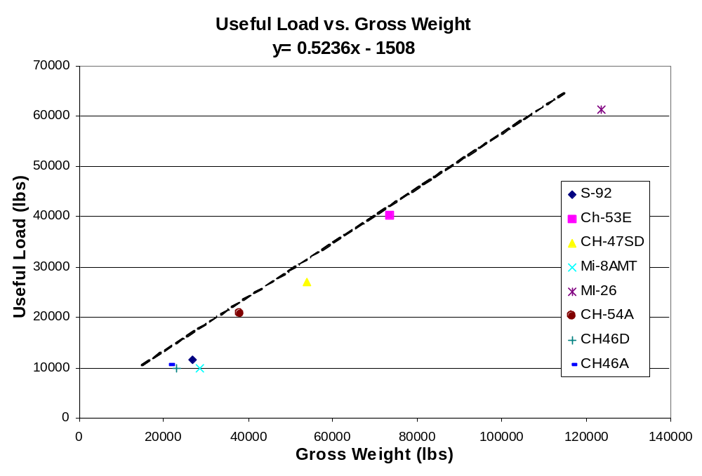
Figure 9.1 Useful Load vs. Gross Weight

9.2 Payload Derivation

The payload is the next necessary step in finding the gross weight of the aircraft. The payload is the aircrafts key requirement and an initial estimated gross weight is determined using this one number and the UL/GW ratio. The payload will consist of the following components: Crew members, rescued victims, the module, cables, the turbine, hydraulics, the clamping device, hoist, and stabilization propulsion system.

9.2.1 Crew Members/Rescue Victims Weight

An estimated weight of 185 lbs was used for the weight of each crew and rescue victim based on average American statistics. There will be a total of six crewmembers onboard the aircraft. In addition the module will have the ability to rescue 200 victims at a time. This will provide a total weight of 38,110 lbs for all humans onboard.

9.2.2 Empty L.I.F.E. Module Weight
A module with a composite skin is used to estimate the initial module weight. The dimensions of the module are 32’x10’x7’ and are used to calculate the volume of the composite skin with a ¾” wall thickness. The composite used is a carbon fiber reinforced plastic with a density of 0.057804 lbs/in³. Using the above information the calculated weight of the module skin was found to be 6485.00 lbs.
Ribs and spars are used as reinforcements to the modules infrastructure. These components will be made of Aluminum 6061-T6 having a density of 0.097544 lbs/in³. Using this specified density the weight was determined to be 428.4 lbs.
The sliding floors will be composed of an Aluminum 6061-T6 skin composed of spars made of the same material. The density of Aluminum 6061-T6 will make each floor have a weight of 531 lbs. Since there will be a total of 4 sliding floors the total weight of the floors will be 2124.0 lbs.
The door weighs 693.04 lbs made of carbon fiber reinforced plastic. The two motors that will be used to operate the doors each weigh 229 lbs. The doors and motors add 1151.04 lbs to the module weight.
Railings, windows, and the clamping beams, will add an additional 2228 lbs.
Adding all the weights of the components gives a total of 12416 lbs for the empty L.I.F.E. module. Solid Works was used to model and calculate all weights for the module. Table 9.1 below summarizes the various components of the empty L.I.F.E. module with the corresponding weight.

Table 9.1 Summarizes the Weight Derivation for the Empty Module

Component | Material | Density | Weight
 |  | (lbs/in³) | (lbs)
Skin | Carbon Fiber | 0.057804 | 6485.00
Ribs/Spars | Al. 6061-T6 | 0.097544 | 428.40
4 Sliding Floors | Al. 6061-T6 | 0.097544 | 2124.00
Railings | Al. 6061-T6 | 0.097544 | 113
Clamping Beams | Al. 6061-T6 | 0.097544 | 1835
Glass Windows | Al. 6061-T6 | 0.097544 | 280
Doors | Carbon Fiber | 0.057804 | 693.04
2 motors | Al/Steel | 0.0400 | 458.00
Total Weight |  |  | 12416.44

9.2.3 Cable Weight

There will be a total of four cables connected to the clamping device to lift the module. The weight of the rope, with electric conductor, is 35-lbs/100 ft. Four cables will be needed for the required load, each greater than 1500 feet in length. If a length of 1600 feet per cable is assumed, the total weight for the system is 2240 pounds.

9.2.4 APU (Auxiliary Power Unit)

A Hamilton Sundstrand 300 SHP (224 KW) Turbo Shaft Engine is used to supply the power to all required components. The dry weight of the APU is 161 lbs when fully installed.

9.2.5 Hydraulics Weight

The hydraulic weight was determined by first starting with the required force to push the clamping device connecting pins. Using a maximum pressure force of 2500 psi, a double acting cylinder with a 4 inch bore weighs 25 lbs. To operate all four cylinders additional equipment is required: pumps, value banks, hoses, reservoirs and hydraulic fluid. The total additional equipment weight comes to 550 lbs for a total of 575 lbs. All data for the hydraulic system was acquired through contact with Central Hydraulics Inc, Martinsburg, PA.

9.2.6 Clamping Device Weight

The overall weight of the hydraulic clamping device is made of the individual components. The first component is the hydraulic system employed on the clamping device, which consists of four hydraulic cylinders along with all of the accessories such as pumps, hoses and fluid. The weights for the hydraulic system can be seen above (Section 9.2.5). Another part of the clamping device is the four pins used to secure the clamping device to the modules. The final component is the frame. The weight of the frame was calculated by knowing the volume found using SolidWorks and material density. The final weight of the clamping device is 2500 lbs.

9.2.7 Hoist Weight

The hoist weight is calculated by summing the individual weights of the parts. Each of the four hoists is made of one motor, gear module, bearings and a reel. The motor that is used is a 230 hp motor with a weight of 270 lbs. The gear module consists of two gears with a combined weight of 80 lbs. The heaviest part of the hoist system is the reel, which weighs in at 225 lbs. The weight was calculated from the material density and the volume of the material. The final component of the system is the bearings. The weight was found from a parts supplier and each bearing weighs 10 pounds. The total weigh of the hoist is 625 pounds. The overall system uses four hoists and the weight of the hoist system is 2500 pounds.

9.2.8 Stability System Weight

The stability system will be attached directly on top of the clamping device for stability and control. Some important components comprising the structure of this system are the air tank, the ducts, the impeller and the engine.

The duct and air tank will be made of Aluminum 6061-T6 having a density of 0.097544 lbs/in³ giving a duct weight of 260.85 lbs and an air tank weight of 100.83 lbs provided by SolidWorks.
The impeller and engine are made of steel AISI C1020 having a density of 0.28356 lbs/in³. The impeller’s weight will be 457.3 lbs and the engine will weigh 1026.02 lbs. The weight of the engine incorporates the fuel tank, which is used only for the propulsion system. However, the engine weight does not include the weight of the fuel.
The weight of the fuel to operate the propulsion system for a mission time of three hours was found to be 227.13 lbs. This is based on a 40-gallon fuel tank and a fuel consumption rate of 0.2222 gal/min.
In addition, miscellaneous parts were estimated to be 115 lbs. Such components are valves, flaps of the ducts, wiring, sensors, and mounting hardware. The summation of the stability system weights can be found on table 9.2.

Table 9.2 Summarizes the Weight Derivation for the Stability System

Component | Material | Density | Weight
 |  | (lbs/in³) | (lbs)
Duct | Al. 6061-T6 | 0.097544 | 260.85
Air Tank | Al. 6061-T6 | 0.097544 | 100.83
Impeller | Steel AISI C1020 | 0.28356 | 457.3
Engine | Steel AISI C1020 | 0.28356 | 497.6
Fuel | Gasoline | 0.024582 | 227.13
Misc. Components | Misc. Material | Misc. Density | 115
Total Weight |  |  | 1658.71

9.2.9 Estimated Fuel Required

The actual UL of the aircraft was determined by summing the estimated weights of each constitute along with the estimated fuel required. The fuel required was estimated by using a specific fuel consumption of 0.4 lbs/hp*hr for turbines. The horsepower was determined by using the most similar analyzed aircraft with respect to lifting capability. Using equation 9.1 the fuel was estimated 16,200 lbs.

Fuel = (sfc)(HP)(M.T.) (9.1)

9.2.10 Summary of Payload and Initial Gross Weight Estimate

Table 9.3 summarizes the total fuel along with the components that comprise the payload. Using Figure 9.1 the UL/GW ratio from existing helicopters was obtained, and the initial gross weight of the Griffin HLRV was determined to be 165,328 lbs.

Table 9.3 Useful Load Determination

SFC | 0.4 | lb./hp*hr
HP | 24000 | shp
Mission Time | 3 | hr
Total Fuel Weight | 28800 | lb
Crew Weight | 1110 | lb
People Weight | 37000 | lb
Empty Module | 12416 | lb
Cables | 2240 | lb
Clamping Device | 2500 | lb
Hoist | 2500 | lb
Total Payload | 57766 | lb
UL (Fuel + Payload) | 86566 | lb
UL/GW | 0.5236
GW | 165328.495 | lb

9.3 Weight Matrix

9.3.1 SolidWorks Weight Matrix

The weight matrix is derived from the models created in SolidWorks. The SolidWorks program calculates the volume and uses the specified inputted densities of each part to determine the weight. The final gross T-O weight is determined to be 162677.44 lbs. This value is used only as a comparison to the weight iteration that was performed using the sum of the individual weights of each component based on estimated gross weight (Figure 9.2).

Table 9.4 SolidWorks Weight Matrix

Aircraft Weights
 | Quantity | Individual Weight (lbs.) | Total Weight (lbs.)
Fuselage | 1 | 15332 | 15332
Rotor | 2 | 6517 | 13034
Landing Structure | 2 | 10683 | 21366
Landing Gear | 5 | 681 | 3405
Split Door Stair Combination | 1 | 434 | 434
Avionics | 1 | 1632 | 1632
Crew Seats | 3 | 210 | 630
Command and Control Unit | 1 | 3515 | 3515
Pilot and Co-Pilot Control Sticks | 2 | 14 | 28
Engines | 2 | 607 | 1214
Gear Module | 2 | 800 | 1600
Small Turn Gear | 4 | 301 | 1204
Large Turn Gear | 3 | 830 | 2490
Cross Shaft | 2 | 447 | 894
Rotor Shaft | 2 | 250 | 500
Flooring | 1 | 3278 | 3278
I-beam (Long) | 2 | 91 | 182
I-beam (short) | 4 | 62 | 248
Glass Windows | 6 | 300 | 1800
Fire Retardant Plexiglas Surrounding | 1 | 1000 | 1000
Fuel Tank (Empty) | 1 | 2325 | 2325
Total: |  |  | 76111
L.I.F.E (Lightning Inhabitant Fire Evacuation) Module
 | Quantity | Individual Weight (Lbs.) | Total Weight (Lbs.)
Carbon Fiber Skin | 1 | 6485 | 6485
Support Spars | 1 | 428.4 | 428.4
Sliding Floor Device | 4 | 531 | 2124
Railings | 1 | 113 | 113
Vertical Lift Door | 1 | 693.04 | 693.04
Vertical Lift Door Motor | 2 | 229 | 458
Clamping Beams | 1 | 1835 | 1835
Glass Windows | 7 | 40 | 280
Total: |  |  | 12416.44
Fire Fighting Module
 | Quantity | Individual Weight (Lbs.) | Total Weight (Lbs.)
Support Frame | 1 | 3852 | 3852
Tank Empty | 1 | 2035 | 2035
Spool | 1 | 500 | 500
Motor | 1 | 486 | 486
Hose | 1 | 1484 | 1484
Water Cannon | 1 | 400 | 400
Piping | 1 | 300 | 300
Pump | 1 | 2000 | 2000
Total: |  |  | 11057
Fuel (Max T.O.)
 | Quantity | Individual Weight (Lbs.) | Total Weight (Lbs.)
Fuel (Max T.O.) |  | 28800 | 28800
Total: |  |  | 28800
Total Payload:
 | Quantity | Individual Weight (Lbs.) | Total Weight (Lbs.)
Hoist System | 4 | 625 | 2500
Clamping Device | 1 | 2500 | 2500
Cable | 4 | 560 | 2240
Crew: | 6 | 185 | 1110
L.I.F.E Module | 1 | 12416.44 | 12416.44
People | 200 | 185 | 37000
Total: |  |  | 57766.44
Gross (T.O) Wieght
 | Quantity | Individual Weight (Lbs.) | Total Weight (Lbs.)
Empty Aircraft | 1 | 76111 | 76111
Fuel | 1 | 28800 | 28800
Total Payload: | 1 | 57766.44 | 57766.44
Total: |  |  | 162677.44

9.3.2 Calculated Weight Matrix

The following weights were found using the initial gross weight as an estimate and then using an iterative process between the power required and the new gross weight found. The process is repeated until the sum of all the components converge to a number (Figure 9.2), that number is the gross weight. The equations used to determine the aircraft component weights were found using a design study formed by Hughes Aircraft Division in 1958; therefore, the weights are determined to be on the conservative side. Using current technology and materials, the weight of the aircraft components can be reduced significantly.

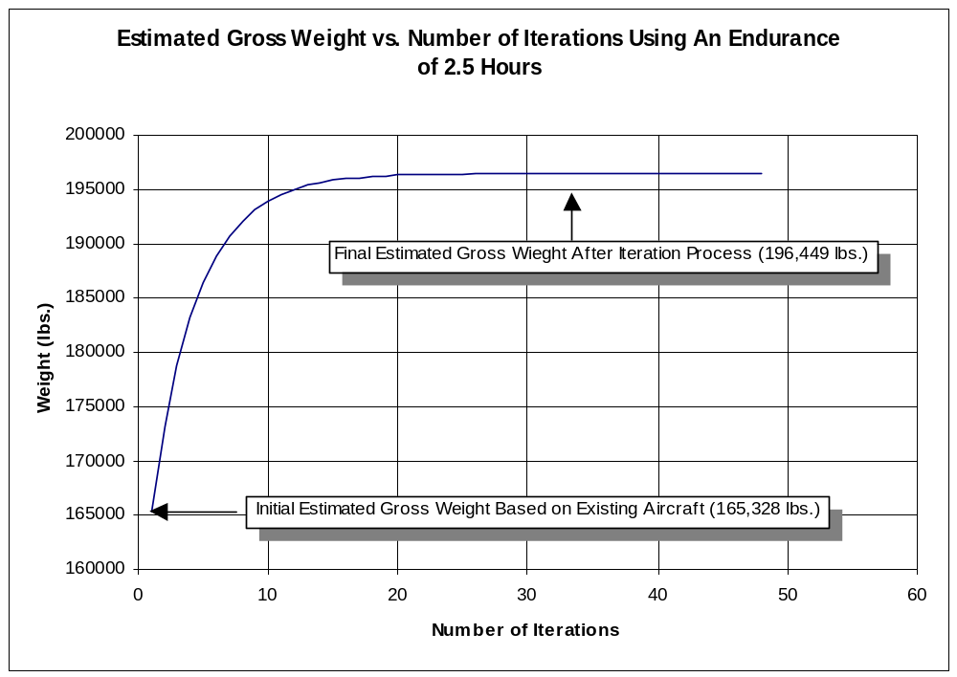

Figure 9.2 The Convergence of the Iteration Process Used to Determine the Estimated Gross Weight.

Table 9.5 Aircraft Component Weights

Aircraft Components |  | Weight (Lbs.)
Rotors (2) | W_{R} (lb) | 12932.10791
Tail | W_{S} (lb) | 6205.962696
Body | W_{F} (lb) | 2253.929533
Alighting Gear | W_{LG} (lb) | 10215.35372
Flight Controls | W_{FC} (lb) | 11469.83087
Misc. Propulsion | W_{PA} (lb) | 7423.822151
Engine | W_{E} (lb) | 14276.58106
Propulsion Rotor Drive System | W_{T} (lb) | 23128.49505
Instrument and Navigation | W_{I} (lb) | 300.971843
Hydraulic and Pneumatic | W_{H} (lb) | 2980.78113
Electrical | W_{EL} (lb) | 1312.542613
Electronics | W_{ET} (lb) | 1138.944695
Furnishings and Equipment | W_{FE} (lb) | 304
Air-conditioning and Anti-Icing | W_{AC} (lb) | 75
Auxiliary | W_{AG} (lb) | 589.3473299
Weight Empty | W_{empty} (lb) | 94607.6706
Useful Load | W_{useful load}(lb) | 2310.532754
Fuel Tanks and Supports | W_{FT} (lb | 2913.831885
Fuel | W_{F} (lb) | 38851.0918
Payload | W_{P} (lb) | 57766
Basic Weight | W_{B} (lb) | 99832.03524
UL/GW |  | 0.503578845
Est Gross Weight (lb) | W (lb) | 196449.11

10. Typical Call and Loading Procedures

This section provides a timeline of the implementation of the conceptual design selected to perform the mission. It will describe the usage of the design beginning with the emergency call to 911 to completion of the mission.

10.1 Instructional Information Sessions

Instructional Information Sessions are an important aspect of the timeline. These sessions are not conducted the day of the disaster rather they are performed even before the Griffin HLRV is ever used. Such sessions will instruct the leaders of the local emergency response teams how to evaluate disasters. The evaluation of disasters will enable the leaders to decide if the Griffin HLRV is indeed necessary to rescue victims as opposed to other available methods.

10.2 Emergency Call

A fire has started in a high-rise building! Upon receiving notification of the disaster the local fire department and emergency response teams that are in the city will be notified of the situation. These units will be dispatched to the location of the site according to the policy and procedures already in place. Once the units are at the site the chief firefighter will communicate with the other emergency team leaders to assess the situation. Their assessment of the situation is vital. It is up to these personnel to make the judgment if the Griffin HLRV emergency response system is indeed needed.

10.3 Notifying Griffin HLRV Headquarters

When the decision to utilize the Griffin HLRV is made by the local emergency response teams, a call is made to the Griffin HLRV Headquarters. The call is made to the headquarters using a phone number that is for such situations only. Such a number will be monitored continuously. In addition, the headquarters may be reached via a specified radio frequency, which is also used only for such situations and open 24 hours a day, 365 days per year.

10.4 Deployment of the System

Once notification has been received that the Griffin HLRV will be needed, the modules will be trucked to the site of emergency. The modules will be preloaded on trucks and ready to go at anytime, night or day. Also the helicopter itself will be deployed from the hanger to the emergency site. The helicopter will approach the emergency site with the specified module attached as determined by the emergency response team at the disaster site. This module will be loaded with 15 firefighter personnel. This will enable the Griffin HLRV to immediately begin rescuing victims upon its arrival. On the way to the disaster site and throughout the duration of the mission, continuous communication will exist between HLRV-Headquarters, deployment trucks, Griffin HLRV, and personal at the disaster site.

10.5 Arrival at Disaster Site

Once the Griffin HLRV arrives at the site it can begin to rescue victims. The manner in which victims are rescued is of course dependent on the initial module already loaded. However, whichever mission is needed to be performed the procedure to accomplish the mission is essentially the same.

The helicopter must strategically position itself so that it can correctly lower the module into place for occupant extraction, firefighter deployment or water deployment. This causes the helicopter to be in hover mode for a substantial amount of time. Depending on what the specific mission is, the mission time will vary.

The following is an explanation of the timeline depending on the first mission being performed upon arrival at the disaster site with the required module:

10.5.2 High Rise Fire Fighter Deployment

Once the module is lowered into place from the hover position, the 15 preloaded firefighters will be deployed on the rooftop or at a specified evacuation site. Once all firefighters have departed from the module, the aircraft will proceed to pick up additional firefighters. The method used to acquire more firefighters is dependent on the location at which additional firefighters are located. There are two primary locations at which these additional firefighters can be positioned which are position 1, and 2 descried below.

- Directly below Griffin HLRV
In reality, this position will not be directly underneath the module of the helicopter, as this will provide unnecessary risk to the mission. Therefore, this position would be located a short distance away from being directly underneath the module on the ground.

- Not directly below Griffin HLRV
This may be the case due to inaccessibility caused by the disaster.

Knowing the location of the fire fighters will determine which acquisition method is used to pick up the additional fire fighters. Described below are the two possible acquisition methods.

10.5.3 Fire Fighter Deployment Acquisition Methods

If the people are located at position one as described above the following method will be used to acquire them

- Directly below Griffin HLRV
The module will be lowered from the helicopter’s hover position to the ground. Upon reaching the ground the personnel will enter the module. Once all personnel are loaded into the module, the aircraft will hoist the module upward while remaining in the hover position. The module will be lifted until the site where assistance is needed has been reached.

2) Not directly below Griffin HLRV
The module will be hoisted upward until it is in flight mode for the aircraft. This will allow the aircraft to begin traveling to the new site in need of assistance and positioning itself in hover position to lower the module or descend to the ground with the module.

10.5.4 Rooftop Occupant Extraction

Once the module is lowered into position to rescue victims from the rooftop it is necessary to open the doors of the module. The preloaded firefighters within the module will aid in the loading of victims as well as perform command and control operations on the rooftop as needed. The estimated time to load the 200 victims into the module with directed help from the firefighters is 2 minutes. Once all the victims are inside the module, the doors will close. The firefighters will then communicate with the command center on the Griffin HLRV that the aircraft is ready to transport the victims. At this time, it is necessary to decide upon a safe area for unloading the victims.

There are two positions for which a safe loading area may be located. These two positions have been described in the above subsection, High Rise Firefighter Deployment – Positions 1, and 2.

Based on the position of the safe loading area a corresponding acquisition method must be implemented. The acquisition method is slightly different than presented in the above section High Rise Fire Fighter Deployment – Fire Fighter Acquisition Methods, and therefore will be stated here.

10.5.5 Rooftop Extraction Acquisition Methods

- Directly Below Griffin HLRV
The module will be lowered from the helicopter’s hover position to the ground. Once the module is on the ground it will be detached and a new module will be attached to continue with the mission. This will save valuable time so that it is not necessary to wait for all victims to evacuate the module before continuing with the mission. This method is possible only if there is sufficient room for the module to be placed on the ground and it has been determined safe to proceed in such a manner.

- Not directly below Griffin HLRV
The second option is to raise the module upward so the aircraft can fly to a safe unloading area. At this unloading area there will be more modules, which can be quickly attached to the aircraft upon deployment of the initial module to save time as previously mentioned.

Once the victims have been unloaded using either of the two acquisition methods the Griffin HLRV can continue with the same module or attach a different module to continue with a different aspect of the mission.

10.5.6 Face Penetration Occupant Extraction

Once the module is in position to rescue victims from the windows it is necessary to open the doors of the module. In addition, the sliding floors must be deployed to serve as a bridge for the victims to enter the module. As with the rooftop operation, preloaded firefighters will provide assistance as needed. The estimated time of loading is the same as rooftop loading time.

One problem that may arise is that all victims are not able to access the module from one location due to inaccessibility caused by the fire. Therefore, there may be numerous evacuation sites on the side of the building. A decision will be made to determine if it is necessary to rescue victims from various locations along the building face before entering the safe unloading area. For example, if there are 100 people close to the top and 15 in the middle it may be more beneficial to rescue the 100 people and unload them as opposed to rescuing both groups of people at the different locations and then unloading them.

Once all the victims are inside the module, the sliding floors will retract and the doors will close. The firefighters will then communicate with the command center on the Griffin HLRV that the aircraft is ready to transport the victims. The same procedure discussed in the Rooftop Occupant Extraction can be used to transport the victims to a safe loading area, where the passengers can be unloaded and a new module attached.

If the mission is water deployment of 4500 gallons with an estimated flow rate of 500 gal./min., this will require 9 minutes.

10.5.7 Disaster Command and Control

Disaster command and control will be continuously performed throughout the mission. Essential communication will take place between the Griffin HLRV and the appropriate ground control forces. Such communication will describe safe loading areas, locations of severe distress, module integration and numerous other aspects. In particular, a specific location onboard the helicopter will be mostly devoted to disaster command and control. This area of the helicopter is called Command and Control Unit.

10.5.8 Water Deployment

Once the module is in position to douse the fire with water, two methods to control the fire may be implored. Both methods can be performed from the same module since self-contained fire fighting capabilities and ground pump water capabilities are incorporated into the same module. Deciding which method to use is a decision made by the command and control personnel at the site.

10.5.9 Self-Contained Fire Fighting Method

Once the module is lowered into place the directed water cannon will be situated to spray the fire with water from the on board water supply. Once the onboard water supply has been depleted, the module will be hoisted upwards so the module is now in flight mode. The aircraft will than proceed to a location to refill the water tank. This area can be a lake, river, ocean or even a near by fire hydrant. Once the aircraft has reached its destination a “SNORKEL” like device will be lowered into the body of water to refill the on board supply. Upon refilling the on board water supply the aircraft will fly back to the disaster site and begin the procedure over once again. However, if the water is to come from a fire hydrant the “SNORKEL” will have to be attached to the fire hydrant by personnel on the ground and disconnected when finished.

10.5.10 Ground Pump Fire Fighting Method

Once the module is lowered into place the directed water cannon will be situated to spray the fire with water from the on board water supply. Simultaneously, a ground pump connecting tube will be lowered so that it can be connected to the ground water supply source. Once connected, the directed fire cannon will continuously spray the fire. Once the fire comes under control the module may be lowered or raised via the hoist to control fires at different levels along the building. If the fire must be fought in a separate location the ground pump connecting tube will be disconnected and the module will be raised upwards into flight mode. The aircraft will then fly to the next location and begin the mission again.

10.6 Refueling

While performing the mission the aircraft will began to lose fuel thus requiring a replenishment of fuel. To refuel, the aircraft must fly back to headquarters or a nearby airport that has been notified of the situation and is available to be used for such a situation. Once refueling is completed, the aircraft will again fly to the disaster site and begin the mission as previously described.

10.7 Mission Completion

Once all victims capable of being saved have been rescued, the aircraft may continue to fight the fire with water and provide disaster command and control operations until deemed unnecessary. Upon the completion of the entire mission the aircraft will fly back to headquarters will it will land and go through rigorous inspection and maintenance so that the aircraft can be used as soon as possible for the next potential disaster.

11. Performance

11.1 Rate of Climb

The rate of climb of the Griffin HLRV was calculated for each mission in loaded and unloaded conditions. The total power required by the Griffin HLRV was first calculated.

The useful power, or that which is required for forward flight, will be zero when the Griffin HLRV is hovering. To find useful power, an average drag coefficient of 0.5 was chosen based on existing helicopter designs. The projected frontal area of the vehicle was estimated to be 414 ft² in hover. In forward flight the Griffin HLRV will fly at 5˚ nose down pitch, increasing the projected frontal area to 1150 ft². Profile power, therefore, increases in forward flight. The total power is given by equation 11.1:

P_{TOTAL} = useful + induced + profile
P_{TOTAL} = DV + 1.15Tω + ρAV_{T}³C_{PP}
P_{TOTAL} = ½ρV²C_{D}S + 1.15Tω + ρAV_{T}³(σC_{D} /8) (11.1)

The inflow in hover can be found using momentum theory:

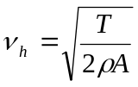 (11.2)

Using simple momentum theory once more,

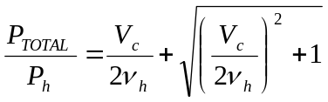 (11.3)

The maximum vertical rate of climb may be found by solving equation 11.3 for V_{C}.

Using this procedure, the maximum rate of climb for each mission was determined and is given in Table 11.1 below.

Table 11.1: Mission-Specific Rates of Climb for Griffin HLRV

Max. Rate of Climb (ft/min)
Rooftop and Side Extraction
No payload | 4633.6
Full payload | 2429.0
Self Contained Fire Fighting
No payload | 4729.3
Full payload | 2688.8
Ground Pump Fire Fighting
No payload | 4729.3
Full payload | 3893.3

11.2 Range

The range of the Griffin HLRV was also estimated from

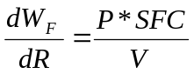 (11.4)

where W_{F} is the fuel flow rate, R is the distance, and SFC is the specific fuel consumption for the engine. The equation was simplified to (11.5) using the following approximations:
- The fuel weight is a small fraction of the total gross weight
- Range data is linear with respect to weight

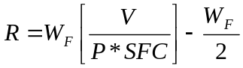 (11.5)

Given the above approximations, the range of the Griffin HLRV is approximately 375 miles.

11.3 Forward Flight

Figure 11.3 shows the maximum flight velocity that the Griffin HLRV can achieve when flying to the building. Both the L.I.F.E and F.I.R.E. modules will be empty during this flight. These velocities can be used to determine how long it will take the Griffin HLRV to arrive at the scene after it takes off. The Griffin HLRV has a high forward flight velocity, due to the extra power it has when it is not carrying the full payload. The Griffin HLRV does not contain the 37,000 lbs of people or water when in forward flight.

The basic equations have slight errors in predicting the power, disk area, and gross weight from the desired flight times. The graphs show that the power is over estimated for long flight times and underestimated for short flight times. This is not a problem, because the desired flight time will be chosen, then the other properties of the Griffin HLRV will be adapted to meet the requirements.

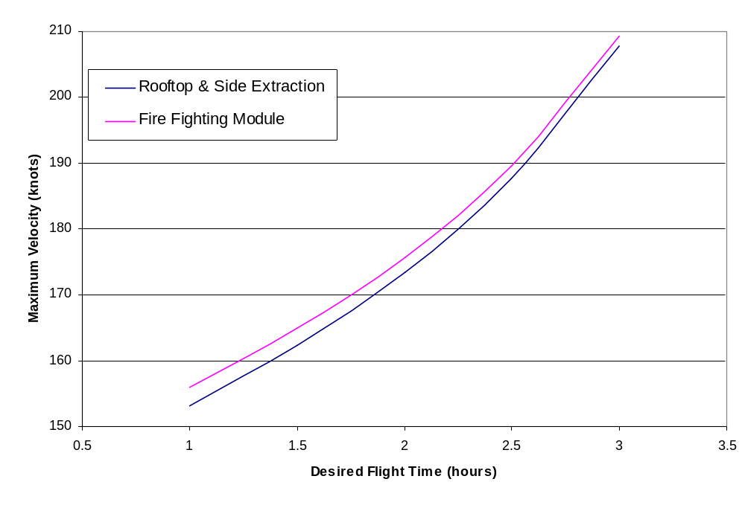
Figure 11.1 Maximum Forward Flight Velocity to Building

11.4 Gross Weight Timelines

The gross weight timelines incorporate the estimated times to perform each objective during a cycle with the amount of weight that each objective inflicts on the gross weight. A detailed timeline, which is explained for each mission, is then obtained for a 1-hour cycle. The timelines can then be used to determine the number of cycles possible in 1 hour and then compared to the given requirements of the RFP. Also the gross weight decreases with each cycle because of fuel usage, which can also be used to determine our total endurance for each mission.

11.4.1 Rooftop Extraction

Figure 11.2 illustrates the mission timeline for rooftop occupant extraction. The timeline follows the assumption that the Griffin can fly to the scene of the disaster in 10 minutes. Once there, it climbs 1500 feet to the rooftop and loads 200 passengers from the rooftop into the L.I.F.E module. With a rate of climb of 1500 feet per minute determined from the performance estimates, the ascent will take one minute. Passenger loading, which will require 2.2 minutes, is based on loading times derived from the SFPE handbook source as follows:

On the rooftop, the victims must traverse the distance to the helicopter once it lands. Using the planform of the World Trade Center as a model, each tower had a square planform 207 feet in width. The victims must cross no more than 125 feet if the helicopter is to have adequate space to land. Therefore, at a travel rate of 190 feet/min, approximated for a situation in which the victims have been traumatized and are in shock, the time to cross the roof is 39.47 seconds.

Assume doorway crush conditions are 0.30 people/ft²; this is an appropriate estimate for a tense setting found in a disaster. Flow is proportional to a rate of one person per second through a three-foot door. As the door to the L.I.F.E module covers the entire side of the module (32 feet), the proportional flow rate is 10.67 persons/sec. This estimate is conservative in that flow rate generally increases at a greater rate than the width of the doorway. Loading 200 victims at a rate of 10.67 persons/sec will therefore require 18.75 seconds.

A time of 30 seconds is also allowed for to open and close the module doors, although this could most likely be accomplished while the Griffin is landing and taking off. Using these estimates, the total time required for loading is 88.22 seconds. If a Factor of Safety of 1.5 is used, the time required is 132.33 seconds, or 2.2 minutes.

Once loading is accomplished the module descends at a rate of 1500 feet/minute and unloads in the same time as loading. This assumes a worst-case scenario in which only one L.I.F.E module may be used and must be unloaded on the ground. Ideally, the module could be set down and detached from the clamping device; another L.I.F.E module would we waiting for attachment, eliminating the need for unloading the passengers quickly.

After unloading is complete, the cycle repeats itself. The decrease in weight seen in Figure 11.5 is due to the fuel consumed during the mission. The Griffin HLRV can rescue 1400 victims per hour using this technique; this not only meets the requirements of 1200 persons/hour but also saves an additional 200 lives.

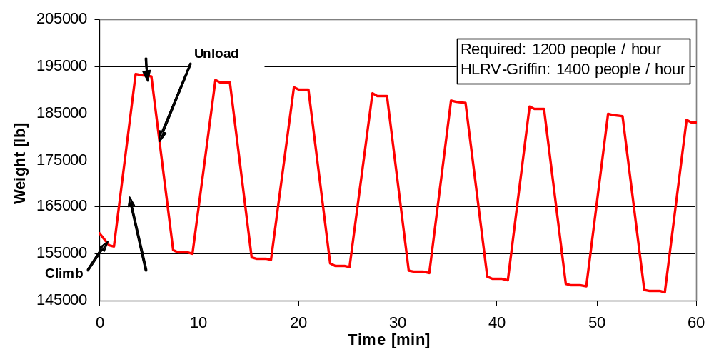
Figure 11.2 Gross Weight Cycle Time for Rooftop Extraction

Figure 11.3 illustrates the rate of fuel depletion for the rooftop extraction mission. The Griffin HLRV has an endurance of 3.16 hours for the mission, allowing for the safe rescue of 4800 victims.

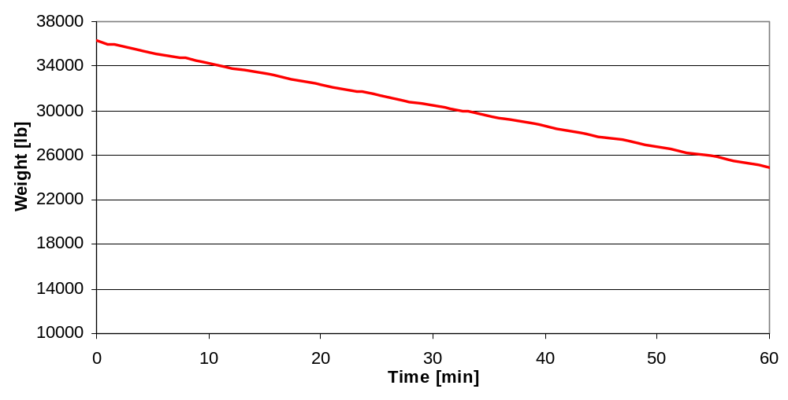
Figure 11.3 Fuel Depletion Rate for Rooftop Extraction

11.4.2 Building Face Penetration and Occupant Recovery

The timeline for building face extraction is shown in Figure 11.4. The pattern is similar to that of rooftop extraction, with some notable changes. Although the rate of climb and descent is the same at 1500 feet/min, additional time is added to allow positioning of the module next to the building, clamping into place, siding out the module floors to fit the contours of the exterior of the building, and breaching the building face. While 200 victims will still be rescued each cycle, loading time is increased to seven minutes due to the much more difficult conditions of rescue. Unloading time, however, remains 2.2 minutes as it is under the same conditions as the rooftop rescue mission. An additional 30 seconds is allowed for once the module has been set on the ground. This allows for assessment of any damage that may have occurred to the L.I.F.E module during building face penetration or attachment as well as additional time to unload any passenger who may have been severely injured due to the much more dangerous nature of rescue.

Four complete cycles can be completed in one hour. This allows for the safe rescue of 800 persons per hour, meeting the requirements of the mission. Mission endurance is 3.31 hours, for a total of 2800 persons can be rescued with the Griffin HLRV from the face of the high-rise building before refueling.

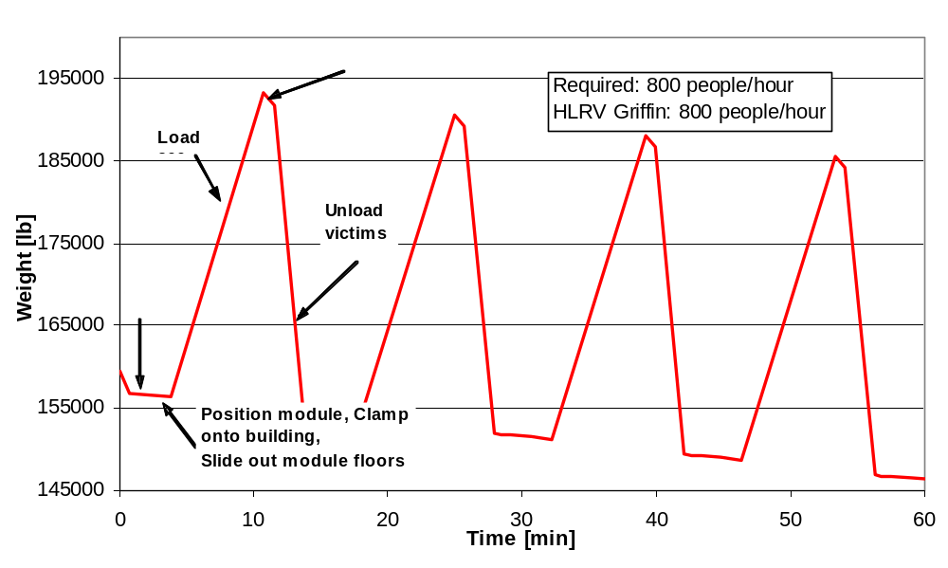
Figure 11.4 Gross Weight Cycle Time for Side Extraction

11.4.3 High-rise Firefighter Deployment

The L.I.F.E module may also be used to accomplish the role of high-rise firefighter deployment. The requirement in the RFP state that the vehicle must “enable delivery of teams of 15 firefighters weighing 300 lbs each with gear to rooftops up to 1500 ft in no more than 2 minute cycles.” As this requires a very aggressive flight pattern it was determined that it would be acceptable to maintain an equal rate of firefighter insertion, equivalent to 450 firefighters per hour.

In the cycle, the rates of ascent and descent of 1500 feet/min were used as in the previous missions. Loading and unloading times were set at 2.5 minutes; although there are fewer passengers than for rooftop extraction, the firefighters were allowed extra time to prepare their gear for the building conditions once they arrive at the scene. Each cycle of firefighter insertion requires seven minutes.

The Griffin HLRV can hold 123 firefighters, each weighing 300 pounds, in the L.I.F.E module. In the span of one hour, eight complete cycles may be completed, allowing for delivery of 984 firefighters to the respond to the disaster. This more than doubles the requirements of 450 firefighters per hour. With a mission endurance of 3.15 hours, a total of 3198 firefighters can be inserted into the building.

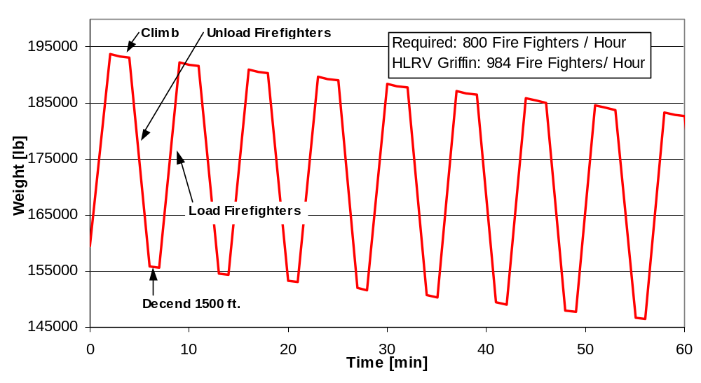
Figure 11.5 Cycle Time for Firefighter Insertion

11.4.4 Ground Pump Water Cannon Fire Fighting

The timeline for ground pump water cannon firefighting is shown in Figure 11.6. The initial increase in weight is due to the weight of the water in the five-inch diameter water hose running from the ground to the helicopter at 1500 feet. Once the hose is filled, the weight of the water will remain constant if the pump operates at a constant speed. The decrease in weight with time is due only to fuel usage. For this mission the Griffin HLRV has an endurance of 3.77 hours.

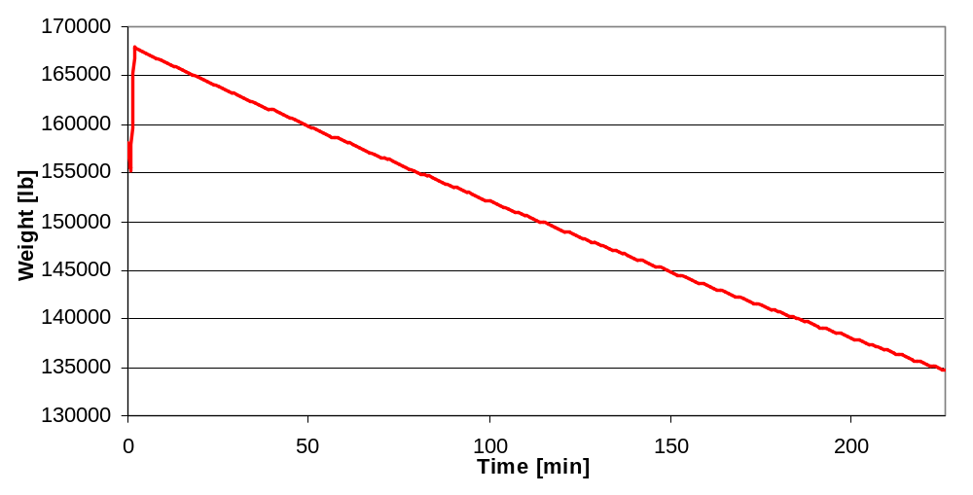
Figure 11.6 Ground Pump Water Cannon Fire Fighting Timeline

11.4.5 Self-contained Tank Water Cannon Fire Fighting

Figure 11.7 displays the cycles for the mission of self-contained tank water cannon firefighting. In this mission, the helicopter fills the tanks on the F.I.R.E. module, climbs to the blazes, empties the entire tank of water, and descends to refill it. The RFP requires that the onboard water tank hold not less than 500 gallons and be refillable in less than one minute for standing water sources or water supplies. Similar to the firefighter deployment mission, it was determined that the rate of water replenishment would be maintained. Therefore, the 4500-gallon tank on the F.I.R.E module will be refillable in eight minutes. As the same onboard pump is used for water cannon firefighting as filling the tank, the F.I.R.E. module will have eight minutes of sustained water cannon firefighting. An additional minute was added to the cycle to account for finding a usable source of water.

One cycle requires 19 minutes, allowing three cycles to be completed per hour. This is equivalent to 13,500 gallons of water being used to fight the high-rise blaze. With an endurance of 2.54 hours, eight cycles may be completed, delivering 36,000 gallons of water.

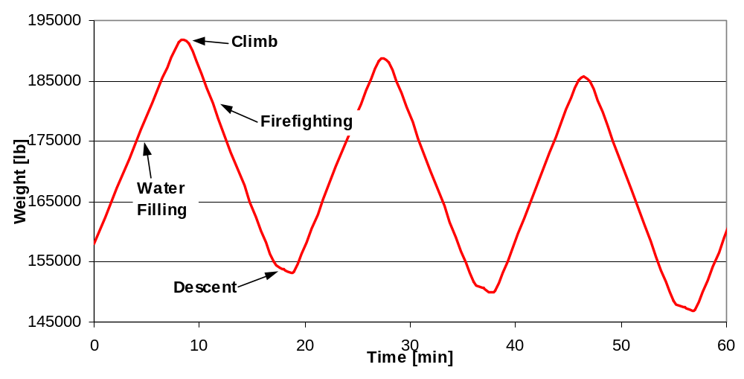
Figure 11.7 Cycle Times for Self-contained Tank Water Cannon Fire Fighting

11.5 Hoist Performance

The Griffin HLRV will employ a hoist system to raise and lower the L.I.F.E. and F.I.R.E. modules. To complete the mission requirements the hoist system is required to lift a maximum design load of 54,156 pounds 1500 feet in less than 60 seconds. This design load includes the fully loaded L.I.F.E. module (200 victims), the STEADY© positioning system, clamping device and 6400 feet of cable (4 sections of 1600 feet).

This is a large task that is accomplished by the use of 4 individual 230HP electric motors. All 4 of the motors work in unison to raise and lower the module. Each motor is attached to a gearbox that drives a 4-foot long 2.33-foot diameter reel. For the load to be raised in under 60 seconds the winch reels will rotate at 185.8 revolutions per minute. This rate takes into account the overlapping windings on the reel.

The gear ratio between the motor and reels will be 5.38 to 1 to provide constant torque, adequate horsepower, and lifting rate. Each motor produces 230HP at 1000 RPM. This is a 200 percent increase in horsepower per motor than is necessary to raise the module. The additional horsepower is used to efficiently arrest the descent of the fully loaded L.I.F.E. module. The Factor of Safety of 2 is also to account for and failures in cables or unforeseen cargo that surpassed the design load.

Table: 11.2 Hoist Performance Parameters

Max Weight lifted (lbs) |  | 54156.44
Time to lift (s) |  | 60
Distance Lifted (ft) |  | 1500
Winch drum diameter (ft) |  | 2.33333
Winch drum length (ft) |  | 4
Cable diameter (ft) |  | 0.083333
Cable length (ft) |  | 1600
Gear Ratio |  | 5.382 to 1

Table: 11.3 Motor Performance Parameters

HP (continuous) | 230
Motor Weight (lbs) | 270
Volts | 380-460
Amps (continuous) | 750
Braking torque | 100%
RPM | 1000

The overall performance of the hoist satisfies the requirements of raising or lowering the modules in 1 minute. There is additional power to safely raise and lower twice the designed payload.

12. Cost Estimates

Naturally a group of undergraduate students lack the resources necessary to do accurate cost estimation; however, using cost estimates of existing aircraft and gross weight scale factors, a reasonable evaluation can be maid.

Cost estimates of the Griffin HLRV were based on the cost estimates done by the 1999 Maryland entry to the AHS competition. Using the gross weight ratio between the two aircrafts as a scale factor, the Griffin HLRV component costs can be found. Table 12.1 shows the gross weight of both aircraft and highlighted in yellow is the general scale factor.

Table 12.1 Gross weight ratio between the Calvert aircraft and the Griffin Aircraft

Gross Weight - Griffin (lb.) | Gross Weight - Calvert (lb.)
196449 | 5067.7
Wgriffin/Wcalvert = | 38.76492294

For a more accuracy individual scale factors were found for each component based on the weight (Table 12.2). Some component weights could not be found for both aircraft. For these components the general scale factor found in Table 12.1 was used to determine cost.

Table 12.2 The weight comparison of the Calvert to the Griffin, used to find the individual weight ratios for the cost estimation

Weights (lb): | Calvert | Griffin
Gross | 5067.7 | 196449.0
Payload and Fuel | 2141.1 | 96617.0
Empty | 2926.6 | 99832
Fuselage | 506.6 | 15332.0
Tail | 22.9 | 6206.0
Rotor Group | 324.8 | 13534.0
Propeller | 131.4 | 0.0
Engine & propulsive sub-systems | 444.1 | 21700.4
Gear box | 347.5 | 1600.0
Cockpit flight control | 53.9 | 11469.8
Main landing gear | 157.0 | 3405
Hydraulic and Pneumatic sys. | 5.1 | 2980.8
Electrical | 176.5 | 1312.5
Avionics | 121.3 | 1632.0
Glass cockpit | 10.1 | 1800.0
Air-conditioning | 59.0 | 75.0

Table 12.3 shows the cost of the 1999 Maryland entry into the AHS competition cost estimation in comparison to the Griffin’s cost determined with the as stated scale factors.

Table 12.3 Cost estimates based on the weight ratios between the Calvert Aircraft and the Griffin Aircraft.

Aircraft Subsystem | Griffin | Calvert
Rotor group | $140,656 | $5,860,955
Tail | $4,594 | $1,244,986
Body group | $133,260 | $4,033,048
Landing gear | $43,457 | $942,491
Air induction | $7,006 | $271,587
Engine | $226,260 | $11,055,916
Drive system | $165,360 | $761,370
Flight controls | $17,795 | $689,822
Instruments | $7,846 | $304,150
Hydraulics | $1,186 | $693,177
Electrical group | $40,605 | $301,959
Avionics | $62,789 | $844,779
Furnishing and equipment | $39,195 | $1,519,391
Air conditioning | $15,551 | $19,768
Load and handling | $6,244 | $242,048
Final assembly | $248,994 | $9,652,233
Tooling amortization and profit | $614,635 | $23,826,278
TOTAL COST | $1,843,904 | $62,263,960

For a sanity check, a comparison was done using existing heavy lift aircraft to see if their cost per pound was similar to the Griffin’s. This was done because the aircraft that was used to determine the cost was much smaller then the Griffin HLRV; therefore, a comparison with similarly sized aircraft was done. It was found that the cost per pound was low. This is mostly likely caused by the significant difference in gross weight of the Calvert and the Griffin. Also the Calvert’s costs were based on estimations made in 1999 which may have some inflationary effects.

Table 12.4 Cost / Lb. of the several exciting heavy lift aircraft compared to the Griffin aircraft

Helicopter | W_{gross} (lb) | Unit Cost | Cost / lb.
CH-47F (ICH) Chinook | 50,000 | $32,000,000 | $640
CH-53 Sea Stallion | 73,500 | $34,605,847 | $471
HLRV Griffin | 196449 | $65,360,885 | $333

13. Development Schedule

The development schedule of any aircraft depends on various key factors, including money, politics as well as the need for that particular type of aircraft. The design team was asked to propose a conceptual design of an aircraft capable of rescuing individuals from a high rise building in an urban area. The following is a breakdown of what is done and what needs to be done to create the first prototype. The development schedule for this particular engineering project can be broken down into three design phases:

Conceptual Design

Conceptual design is characterized by a large number of design alternatives, trade studies and a continuous evolutionary change to the aircraft concepts under construction. It is the conceptual design that the basic questions of configuration arrangement, size and weight and performance are answered. Also, the various technologies to be used are determined.

Preliminary Design

The preliminary design stage is where the major changes in the design cease. This is the stage characterized by a more complex design approach, which may take months. Specialists from various areas such as structures, landing gear, control system design and analyze their portion of the aircraft. Also, a process called “lofting” will be undertaken on the aircraft. Lofting is the mathematical modeling of the outside skin of the aircraft with sufficient accuracy to ensure proper fit between its different parts. At the end of the preliminary design stage, a proposal is presented to the company responsible for building the aircraft. The proposal answers the question whether or not the aircraft can be built with the given capital and in the given time. There is also a reliable cost estimation that is obtained in the proposal.

Detail Design

The detail design stage of the aircraft involves designing and fabrication of actual pieces as well the testing of major components. Every piece of the aircraft’s structure and its hydraulic, electrical, pneumatic, fuel and other systems must be designed in the detail design phase. This is the last and most expensive part of the design process and involves hundreds of complex CAD drawings with actual fabrication geometries and dimensions. Detail design ends with the fabrication of the first aircraft. Usually the prototypes are built on temporary tooling and are often built with fabrication processes different from those envisioned for the production run.

As mentioned previously, the actual production and its pace also depend on Non-Engineering factors.
Aircraft cost estimation and production occupies the gray area between science, art and politics. This particular aircraft could take a decade for all the research and testing and development to be completed, but the overall speed at which it will be available for customer use will depend on the money invested in this project as well as it being given a top priority in the company.

Figure 13.1 displays the development schedule in the form of a Gant-chart. The first fabrication date will be in the year 2014.

 |  | 2002-2003 | 2003-2004 | 2004-2005 | 2005-2006 | 2006-2007 | 2007-2008 | 2008-2009 | 2009-2010 | 2010-2011 | 2011-2012 | 2012-2013 | 2013-2014
Conceptual Design | Establish design parameters, development of 3-view diagrams
 | Developing preliminary layouts, architecture selection and finalization for various systems
 | Feasibility study and layout generation for various mechanisms
Stress Analysis  and Optimization | Design and Analysis of Engines
 | Estimation design of allowable Stresses
 | Modeling and buckling Analysis
 | Vibration Analysis and optimization
 | Fatigue and Damage tolerance analysis of rotor components
 | Finite element analysis of helicopter fuselage and tail boom
Design and Modeling | Design and development of assembly study of transport module
 | Routing and modeling of pipe lines on aero-engine
 | Generation of mock drawings and airframe layout for the aircraft
 | Layouts, assembly, sub-assembly, part drawings, detail design of various stages of the helicopter
 | Computer simulation of structural and aeronautical aspects of the helicopter
 | Methodizing/processing planning of machined/formed/welded items
 | Final assembly of all the components
 | Fabrication of first aircraft

Figure 13.1 Development Gant-Chart

14. Risk Identification and Risk Reduction Plan

The ability to safely operate the Griffin HLRV is of the utmost importance before fully integrating the design to real world applications. Safety measures must be identified and dealt with before the Griffin HLRV performs its first mission. Doing so will significantly reduce the number of accidents, deaths, and casualties. The following section will describe inherent risks and procedures to help minimize such safety risk.

14.1 Instructional Information Sessions

It is necessary to ensure the integration of the new rescue procedure with pre-existing rescue methods currently being utilized. These sessions are not conducted the day of the disaster rather they are performed even before the Griffin HLRV is ever used. Such sessions will instruct the leaders of the local emergency response teams how to evaluate disasters. The evaluation of disasters will enable the leaders to decide if the Griffin HLRV is indeed necessary to rescue victims as opposed to other available methods.

Communication from the ground is vital during times of crisis. The local police and firefighters on the ground will need to be in constant communication with the Griffin HLRV crew. Topics specific to the mission will be covered in depth. Such topics will include the identification of a safe landing zone, decisions to determine if it is possible to lower the module for unloading or not, and how to effectively incorporate the mission command and control center located on the Griffin HLRV with the ground crew to name a few.

Fire fighters will have to be selected and trained for High Rise Fire Fighter Deployment missions. It is necessary for the fire fighters to become familiar with directing victims safely and quickly into the modules. In addition, they must be taught the mechanics and controls of the modules themselves. These controls will include the opening/closing of module doors and the extraction/retraction of sliding floors.

Pilots for flying the Griffin HLRV must be subjected to intense training. The training will inform them of the new capabilities and new design features of the Griffin HLRV. The details of the rescue methods must be extensively covered and explained for efficient implementation. Carrying a live payload in modules is a rare task pilots perform. Therefore, pilots with the ability to operate aircraft with sling loads will be a plus.

14.2 On Scene Risk Reduction Precautions

Conducting seminars and training before performing the mission can prevent risks that can be encountered on the mission. Risks will be encountered during the mission and there must be ways to minimize such risks.

The safety of the victims is of great concern. For this reason, each module will be equipped with safety equipment. Such equipment will include standard first aid kits, fire extinguishers, handrails and safety straps as seen on trains for standing passengers.

At each loading zone, the EMS will have complete access to tend to the needs of the victims. Additional training of EMS will not be required since they already are trained for emergency situations.

14.3 Post-Mission Risk Reduction Precautions

Upon using the Griffin HLRV to save victims from a disaster scene, the aircraft and all of its components will be subjected to intense inspections and maintenance criteria. Such criteria will test electronics, structural integrity, movable parts, modules and so on. If the aircraft is unable to pass maintenance and inspection for any reason, it will not be allowed to fly until all problems have been adequately rectified.

15. Number of Systems per 1,000,000 People

In determining the number of systems necessary to efficiently rescue victims in a city of 1 million there are several factors that are to be taken into account. The Department of Public Health (DPH) considers the factors listed below:

- Population to be served by the proposed service;
- Geographic area to be served by the proposed service;
- Volume of calls for the previous 12 months within such areas;
- Potential improvement in service in the area including cost effectiveness and response times;
- Location of the proposed principal and branch places of business in relation to health facilities and other providers;
- Need for special services, if applicable
Population density is used to determine the number of units required to fulfill the needs of 1 million people. To correctly calculate the population densities, American cities with at least 1 million residents were surveyed. These cities included New York, Los Angeles, Chicago, Houston, Philadelphia, San Diego, Phoenix, San Antonio and Dallas. It was found that the average population density of all above listed cities was 30274 people per square mile. This density includes NYC with a population density of 240,188. Excluding NYC the average population density of the remaining cities is 4035 people per square mile.

It was calculated from the number of ambulances for a city population that 1 ambulance can efficiently handle all calls for 4545 people. This is a worst-case scenario assuming that an ambulance can rescue or treat one victim at a time. Using this scale and the fact that Griffin HLRV can rescue 200 victims at once, it is seen that 1 HLRV system can safely and efficiently provide coverage for 909000 inhabitants. For a city with a population of 1 million, the recommended number of systems based on population density is 1.1 Griffin HLRV systems.

16. Concept Sketch of Future Station

Figures 16.1 and 16.2 show how a possible future high-rise rescue fire station might look. The roof will have a large helicopter pad for landing the Griffin HLRV onto, and at the street level there will be a large opening for tractor trails to be deployed. The station will be a large warehouse where modules can be stored and replenished.

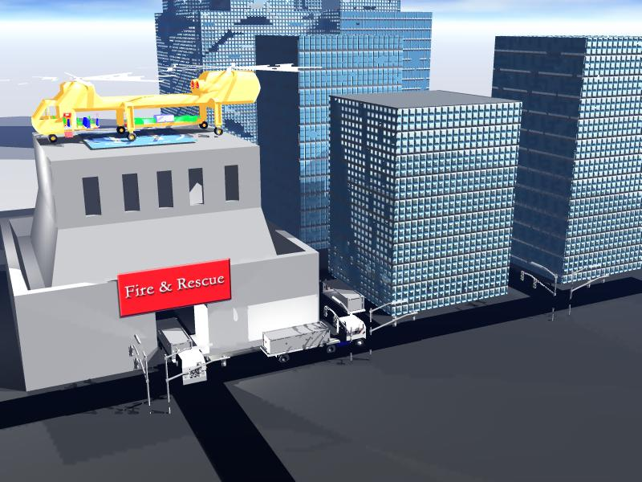

Figure 16.1 Day Time View of a Possible Griffin HLRV Fire Station, Located in the City

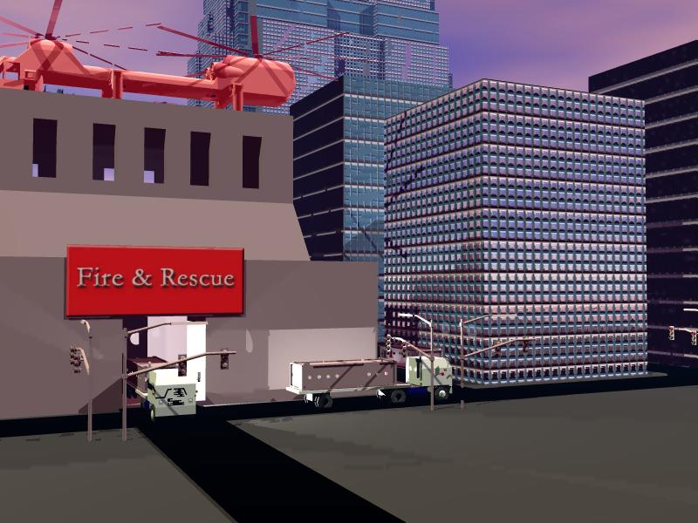

Figure 16.2 Night Time View of a Possible Griffin HLRV Fire Station in Action

17. Greek Mythology

Greek Mythology of the Griffin

The Griffin is a mythical creature that has the head and wings of an eagle and the body of a lion. Griffins are usually heroic-like symbols. They are well known for their speed, ability to fly and having eyes like an eagle, as well as the strength and courage of a lion. In hieroglyphics, griffins represent heat and summer. In Assyria (an ancient empire of western Asia) both the griffin and the dragon were symbols of wisdom. In Roman art, griffins are often pulling the chariot of Nemesis (goddess of justice and revenge.)

18. References

1. Baum, H.R., D.D. Evans, G.P. Forney, K.B. McGrattan, W.M. Pitts, K. Prasad, R.G. Rehm. “Initial Model for Fires in the World Trade Center. National Institute of Standards and Technology: Gaithersburg, MD. 2002.

2. Crabtree, James. “Weight Estimation for Helicopter Design Analysis.” The Society of Aeronautical Weight Engineers, Inc. Technical Paper No.177

3. Davis D., William, “Comparison of Algorithms to Calculate Plume Centerline Temperature and Ceiling Jet Temperature with Experiments”, January, 2000 http://fire.nist.gov/bfrlpubs/fire00/PDF/f00010.pdf

4. Heskestad, Gunnar. “Fire Plumes.” The SFPE Handbook of Fire Protection Engineering. Ed. by Beyler, C.L. National Fire Protection Association: Quincy, MA. 1988.

5. Jackson, Paul. Jane’s All the World’s Aircraft. Jane’s Information Group Limited

6. MacLennan, H.A. and H.E. Nelson. “Emergency Movement.” The SFPE Handbook of Fire Protection Engineering. Ed. By Beyler, C.L. National Fire Protection Association: Quincy, MA. 1988.

7. McCormick, Barnes. Aerodynamics, Aeronautics, and Flight Mechanics. John Wiley & Sons. Hoboken, N.J.

8. Pauls, Jake. “Movement of People.” The SFPE Handbook of Fire Protection Engineering. Ed. By Beyler, C.L. National Fire Protection Association: Quincy, MA. 1988.

9. Prouty, Raymond. Helicopter Performance, Stability and Control. Krieger Publishing Company: Melbourne, FL. 2001

10. Raymer, David. Aircraft Design: A Conceptual Approach. American Institute of Aeronautics and Astronautics Inc. Reston, VA. 1999

11. The Old Farmer’s Almanac: “Weather History”, www.almanac.com/weatherhistory/index.php

12. Raytheon Company. “Boca Raton Test Report: Air-to-Ground Video Tests”. February 5-7, 2003.

13) Rotor & Wing: Defense Daily Network, June 2002, Global Security.org

14) Maryland '99 Design Project, http://www.enae.umd.edu/AGRC/Design99/calvert.pdf

15) NASA-Ames Technical Publications, http://halfdome.arc.nasa.gov/publications/pub.html
16) Material Properties, http://www.psyclops.com/tools/technotes/materials/density.html
17) Greek Mythology, http://www.kidzworld.com/site/p1932.htm

